Experiment-01-Network-Components
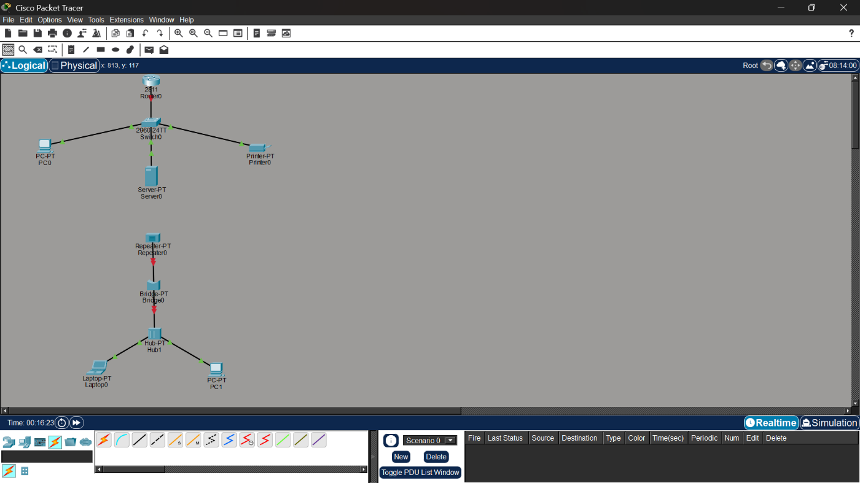

Experiment-02-Star-Topology
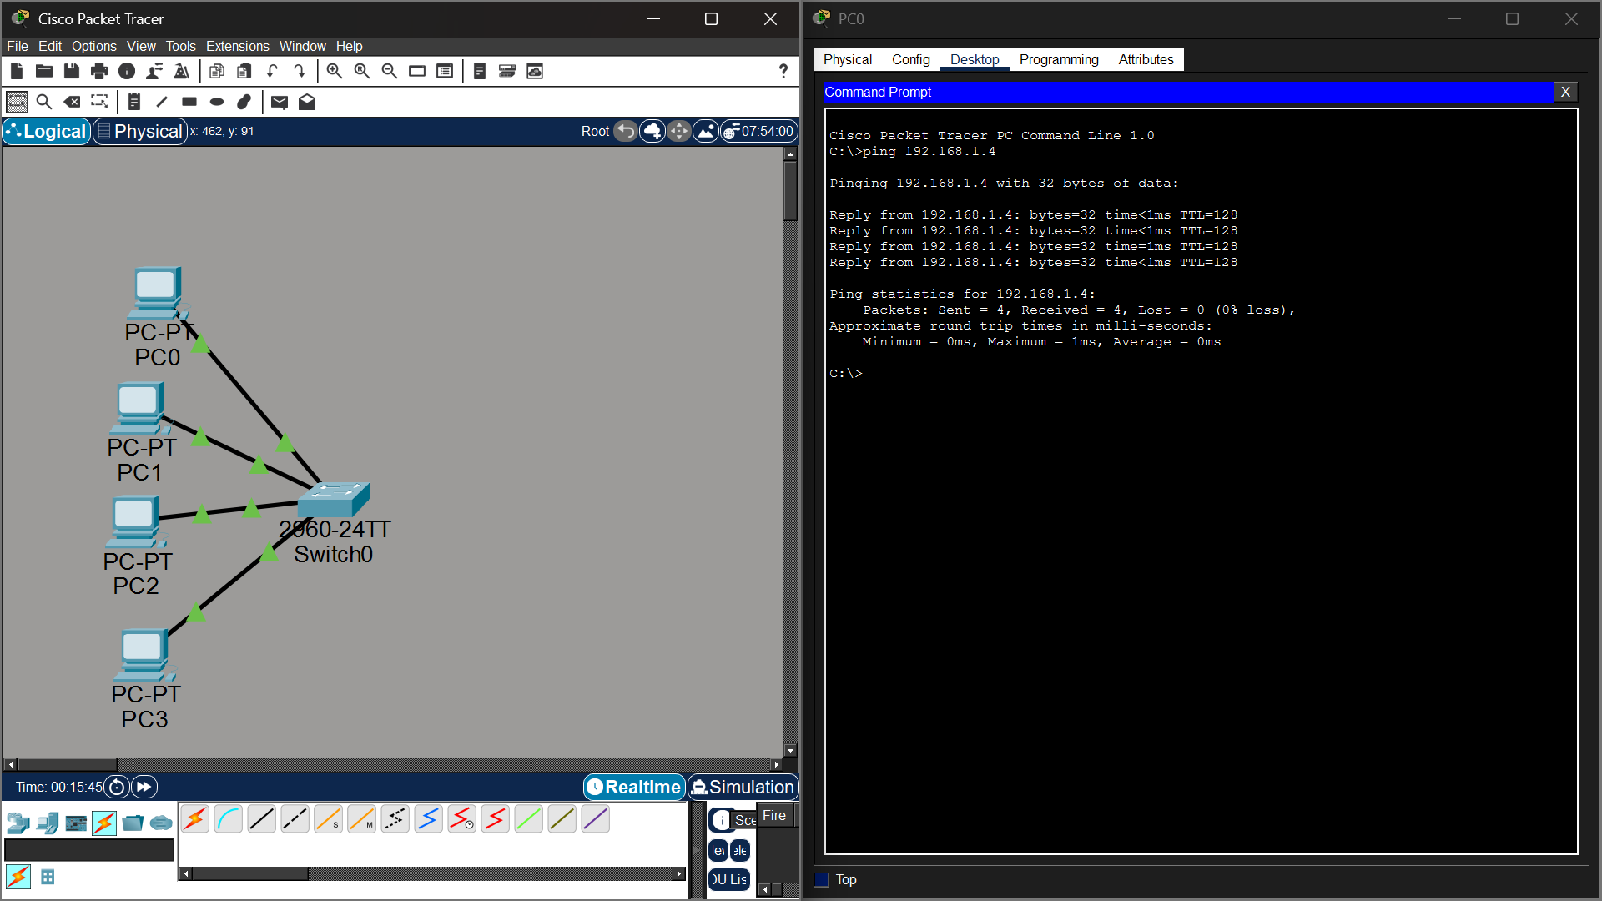

Experiment-03-Bus-Topology
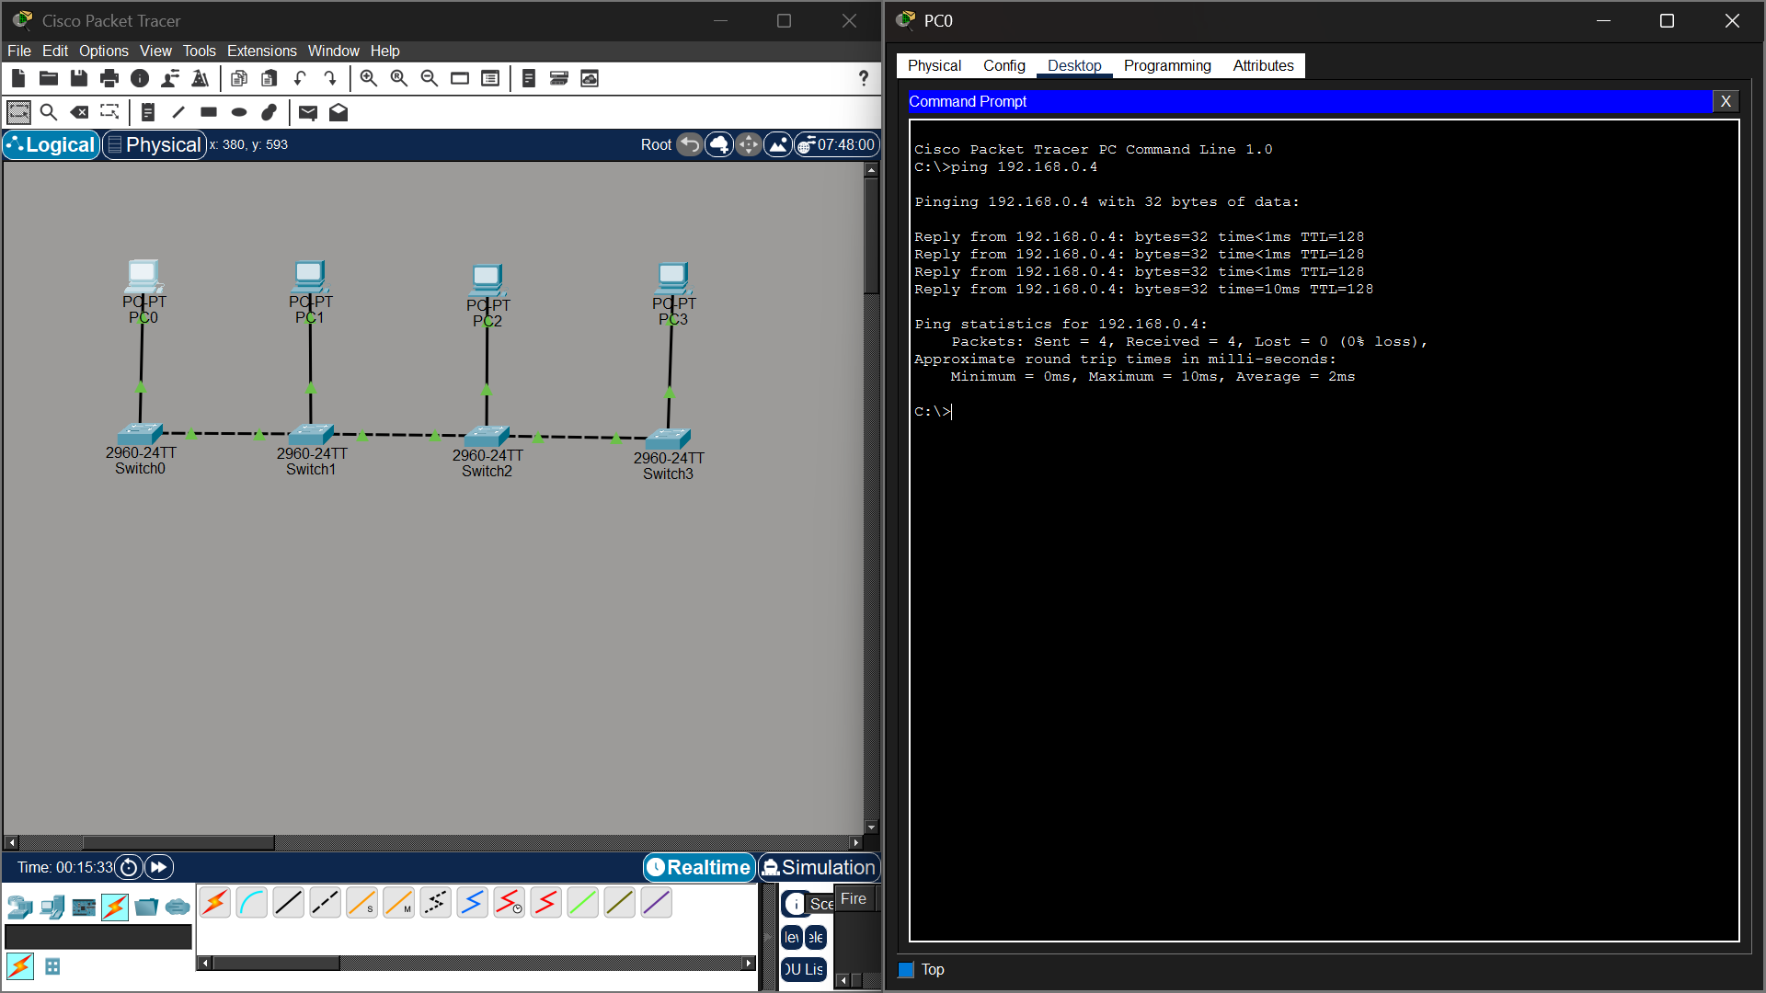

Experiment-04-Ring-Topology
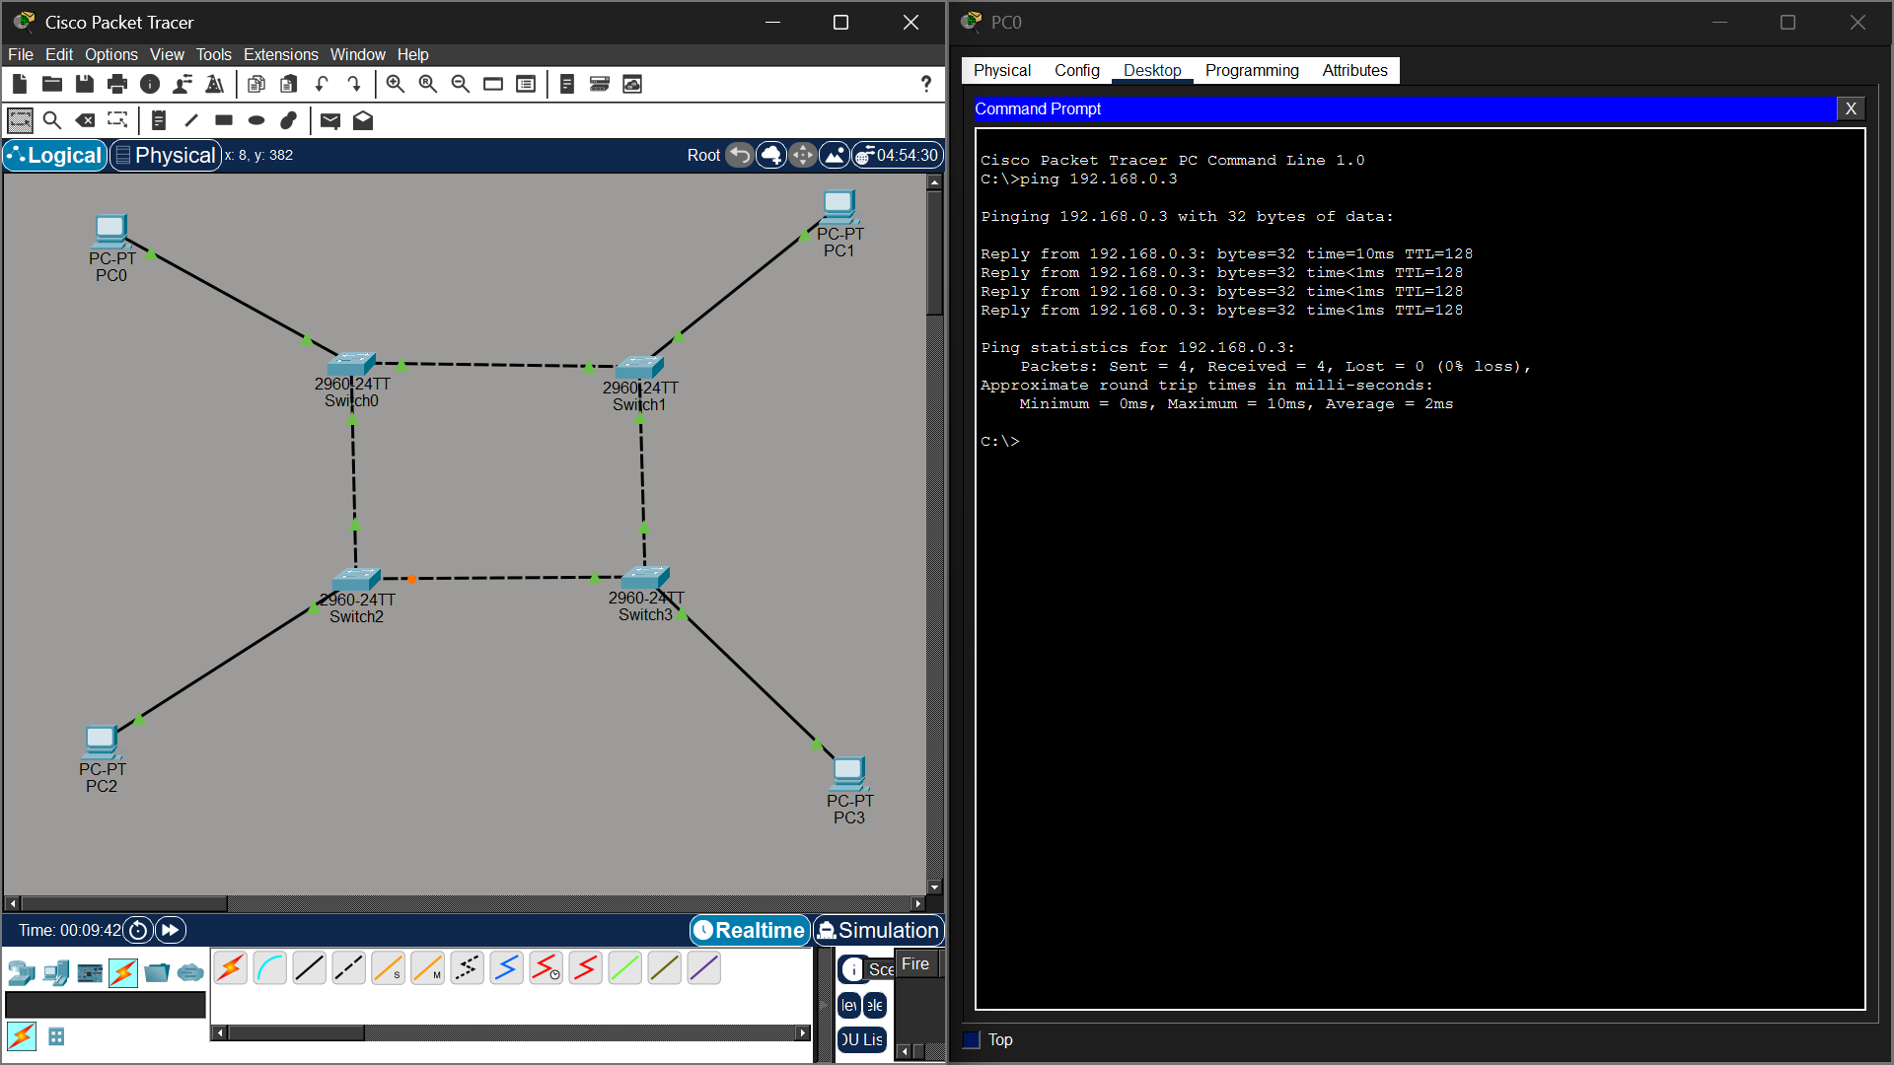

Experiment-05-Mesh-Topology
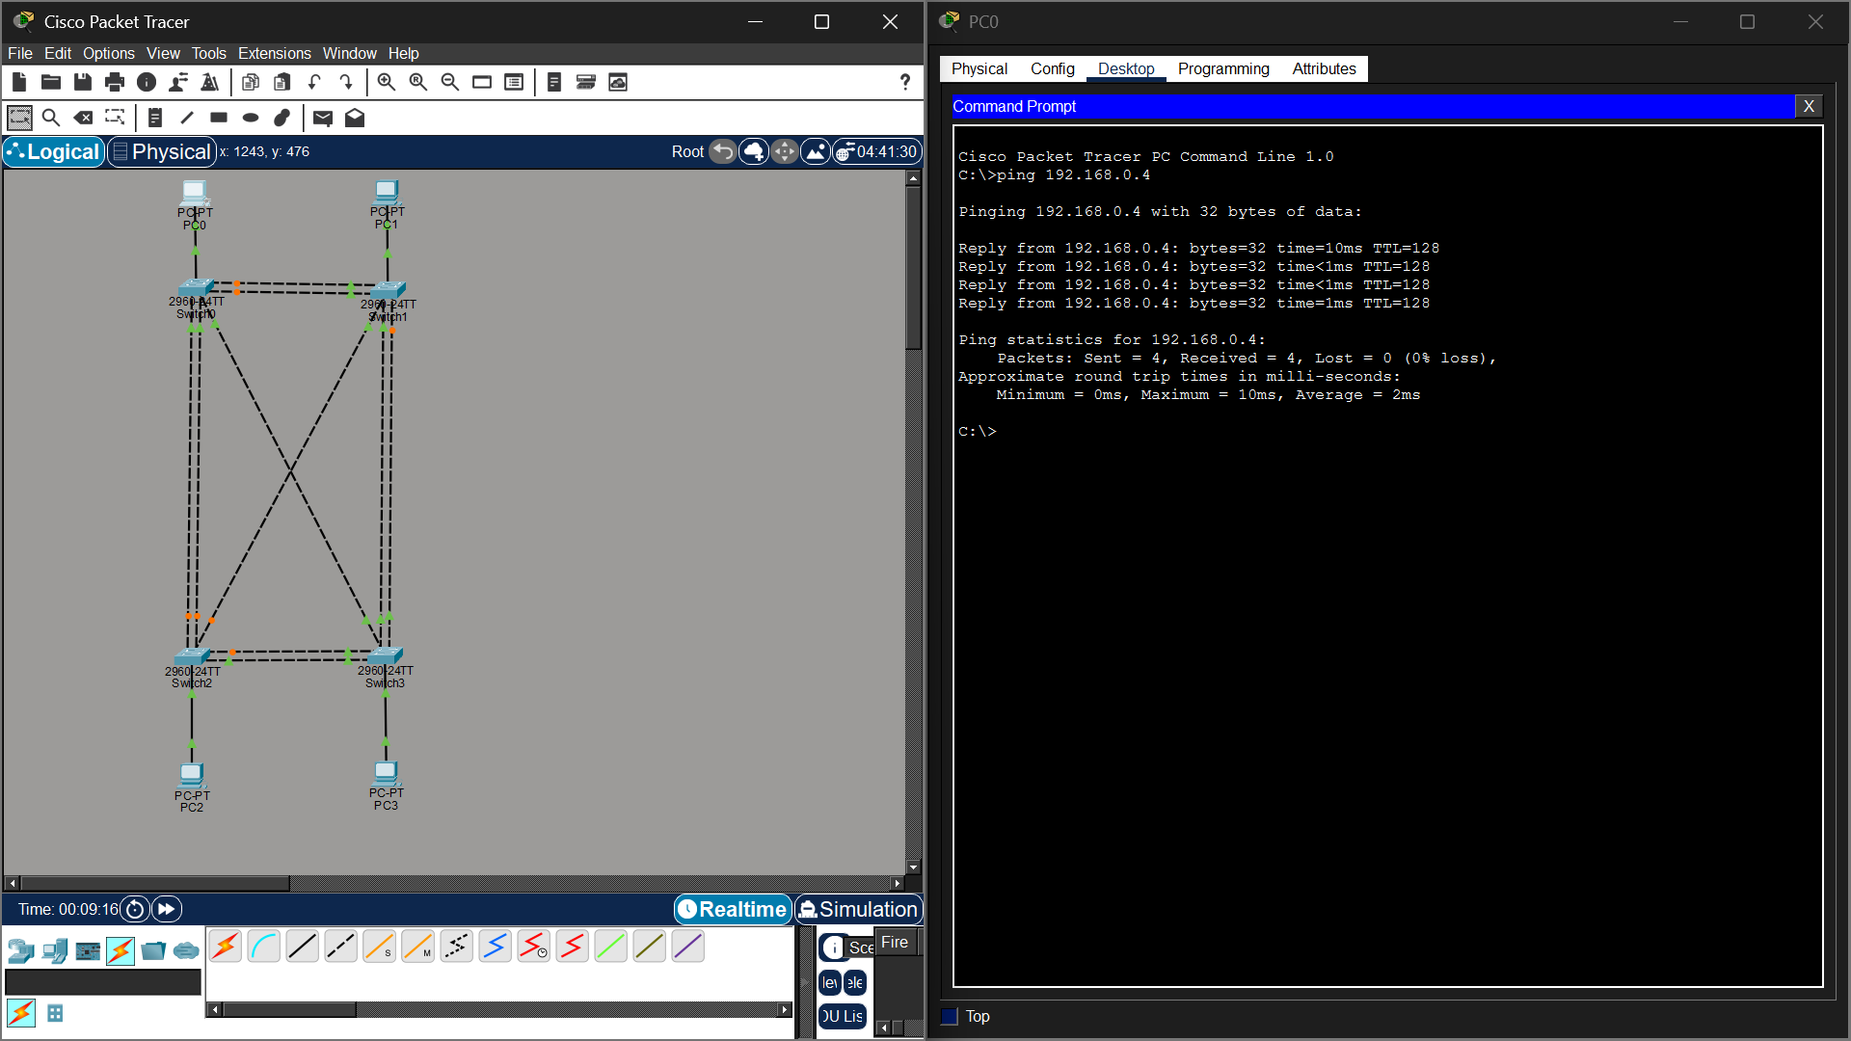

Experiment-06-Tree-Topology
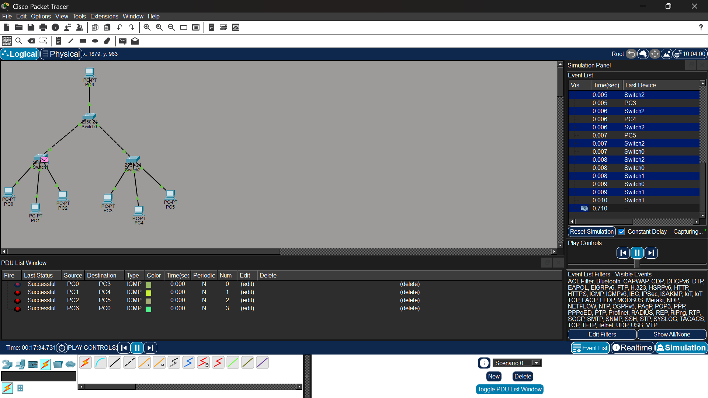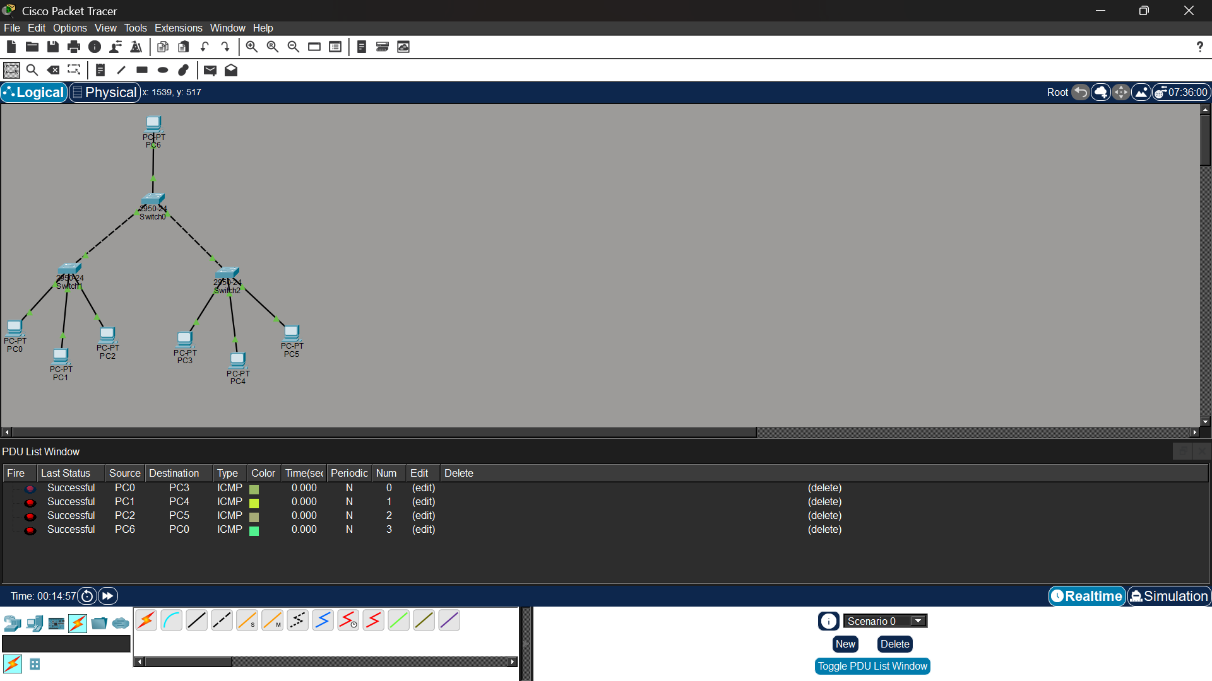

Experiment-07-Hybrid-Topology
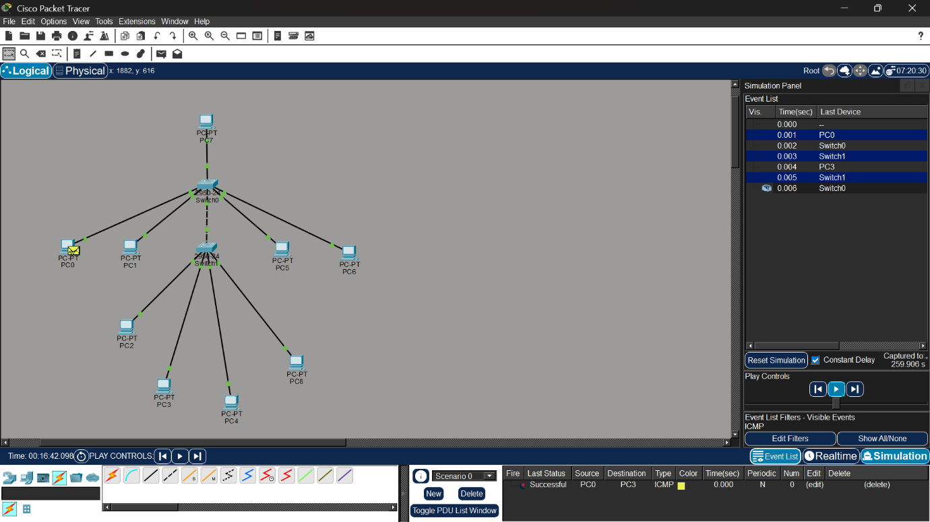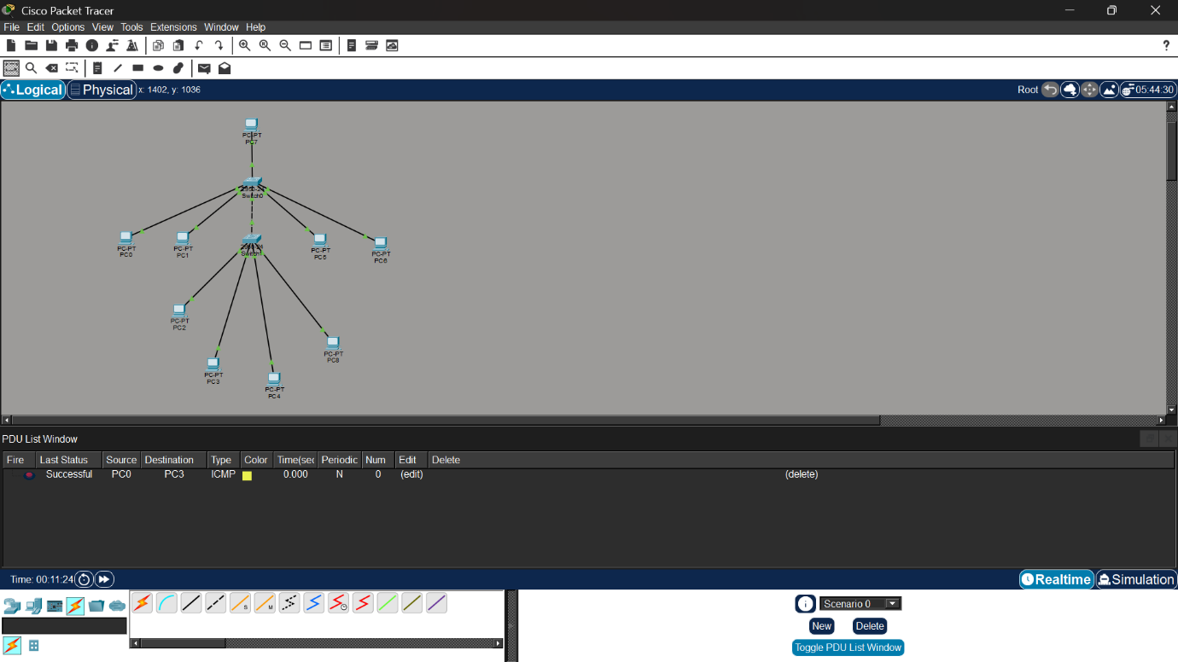

Experiment-08-ARP-Analysis

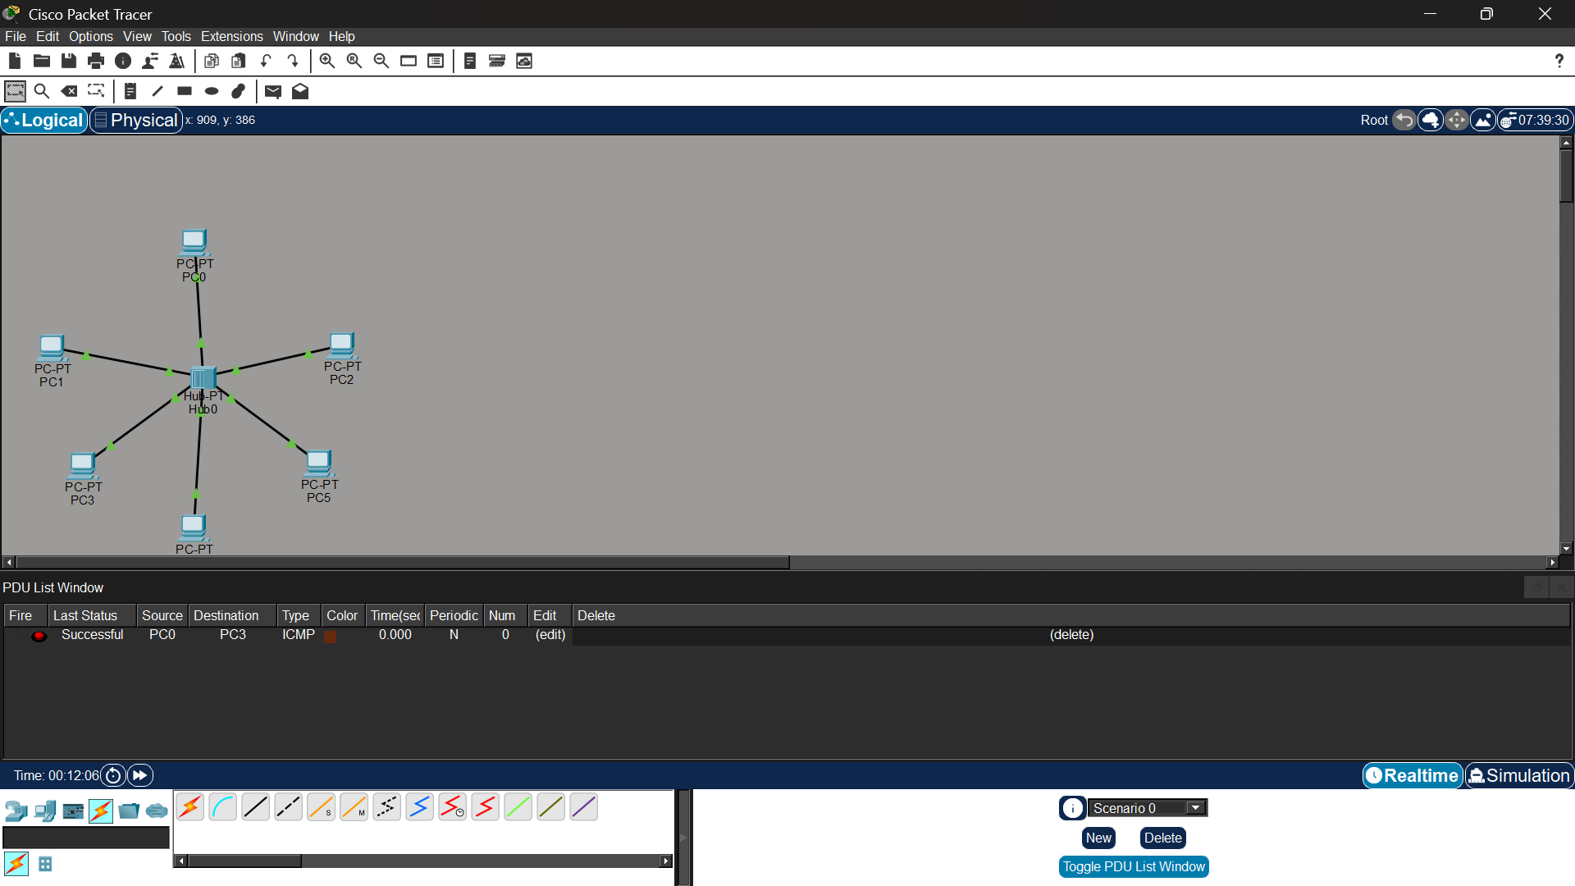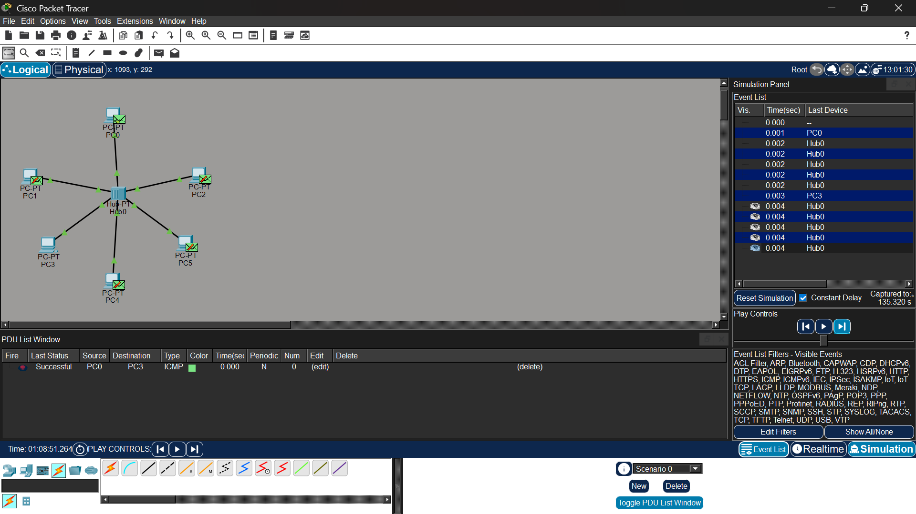

Experiment-09-CSMA-CD-CSMA-CA
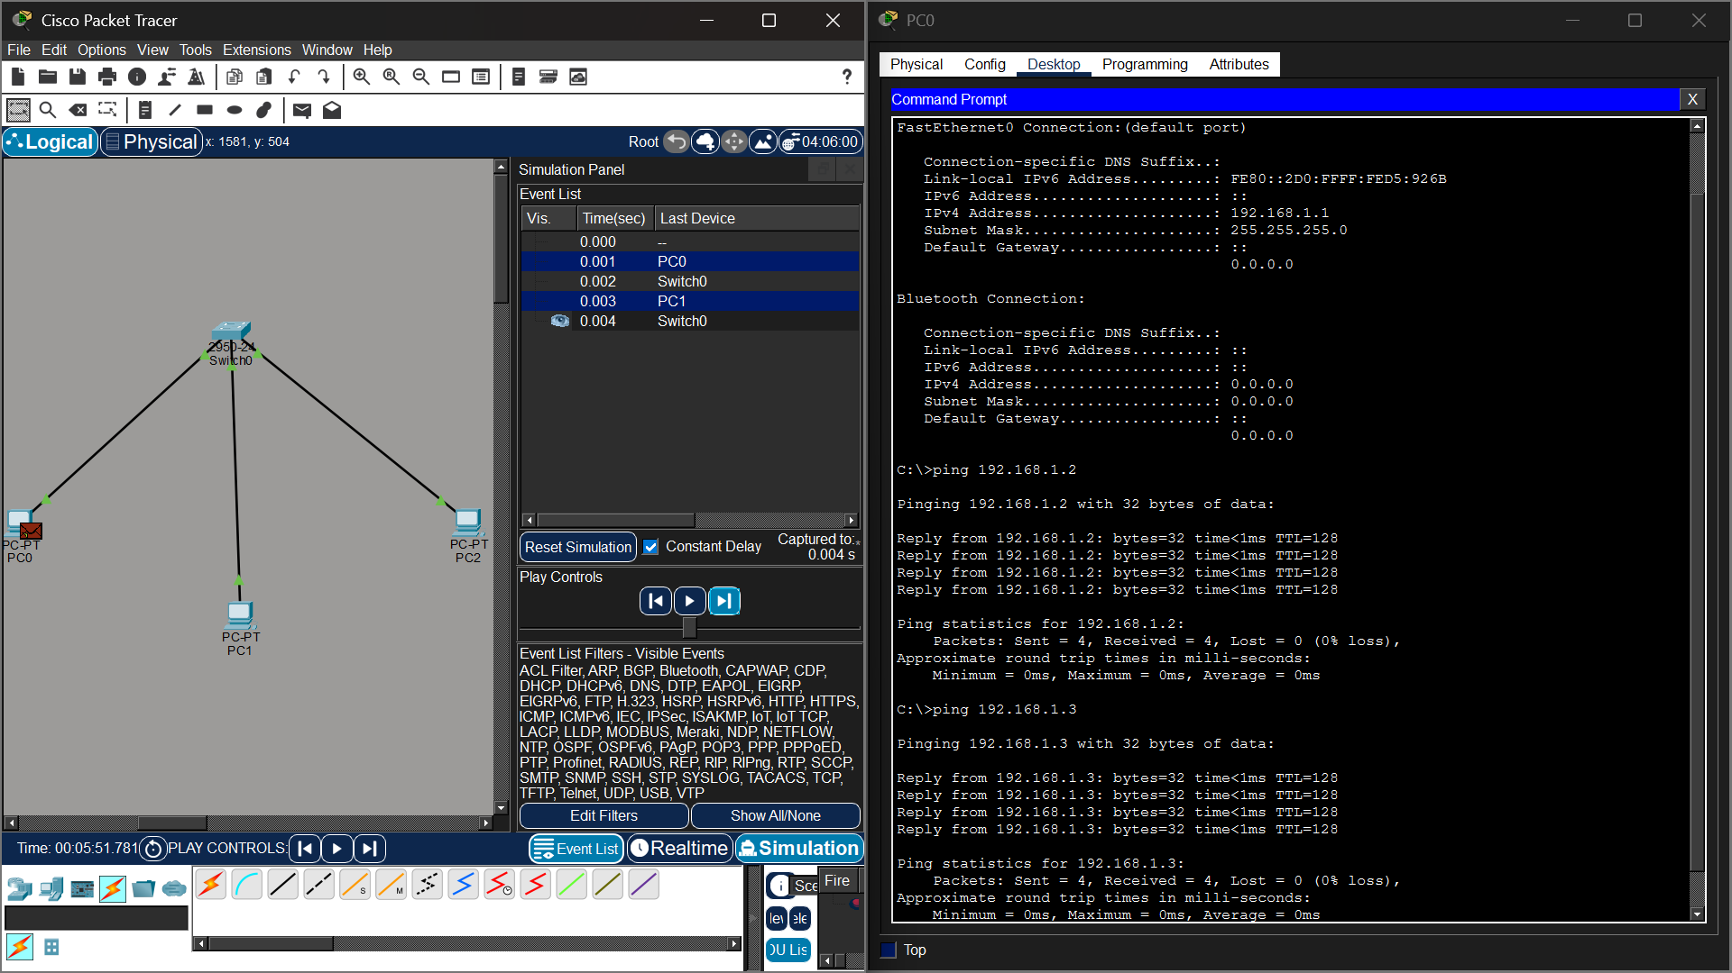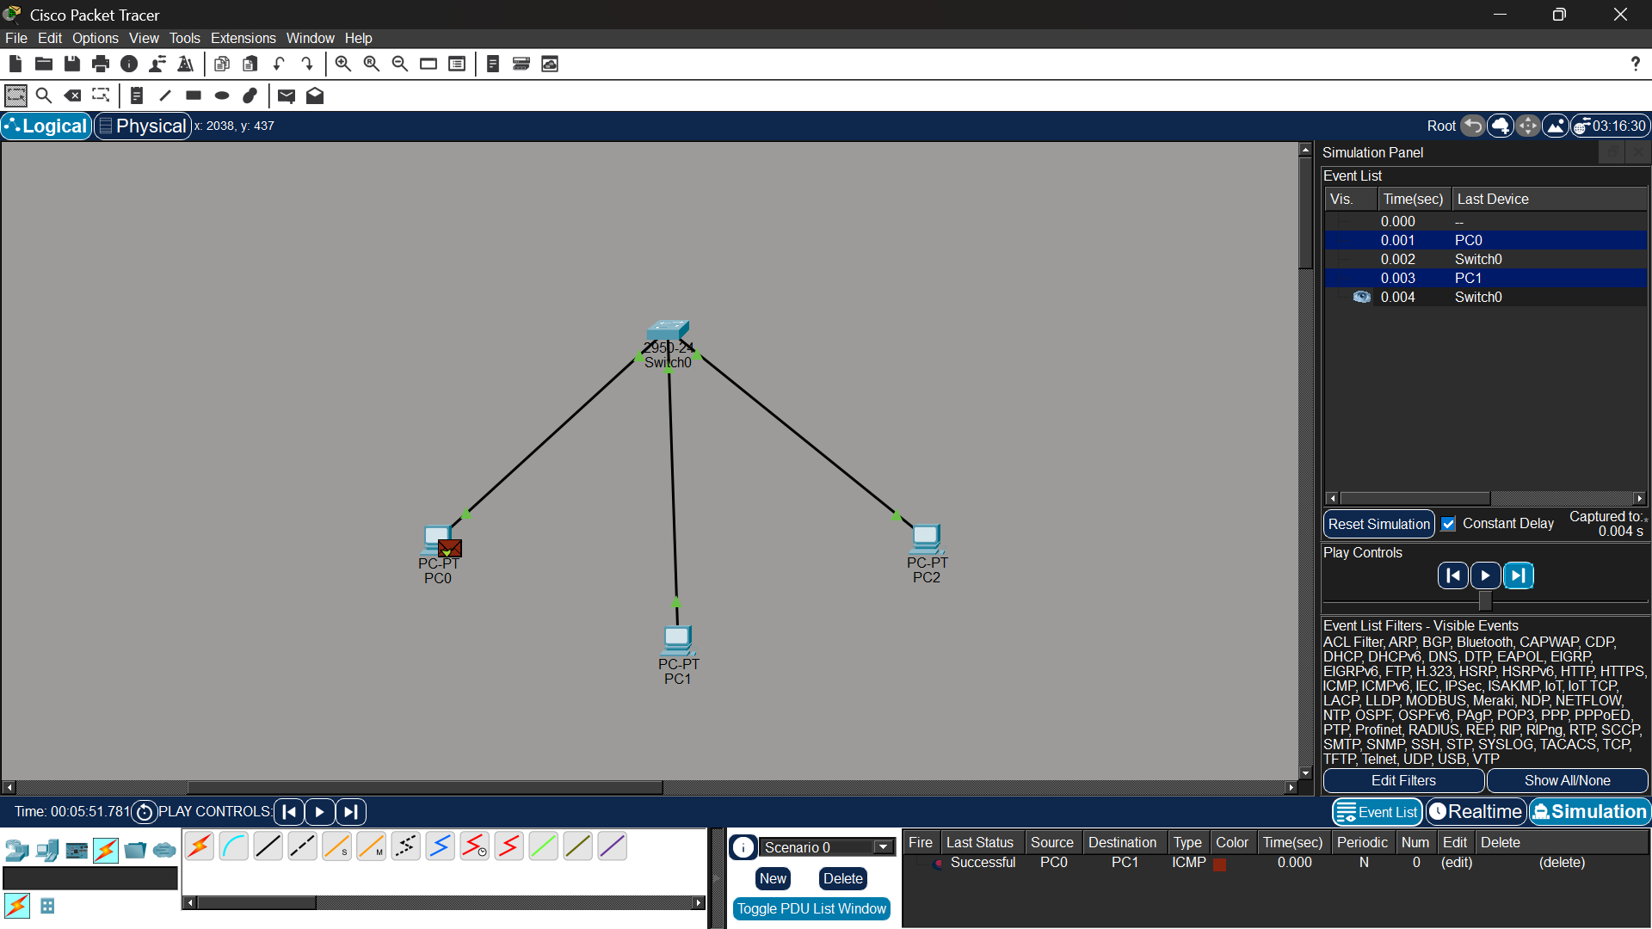

Experiment-10-Computer-Lab
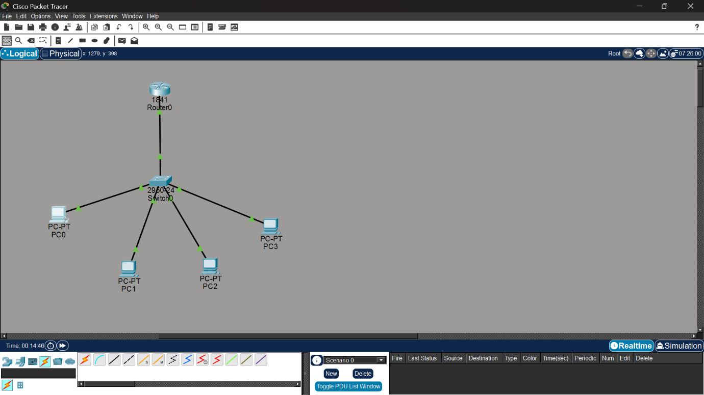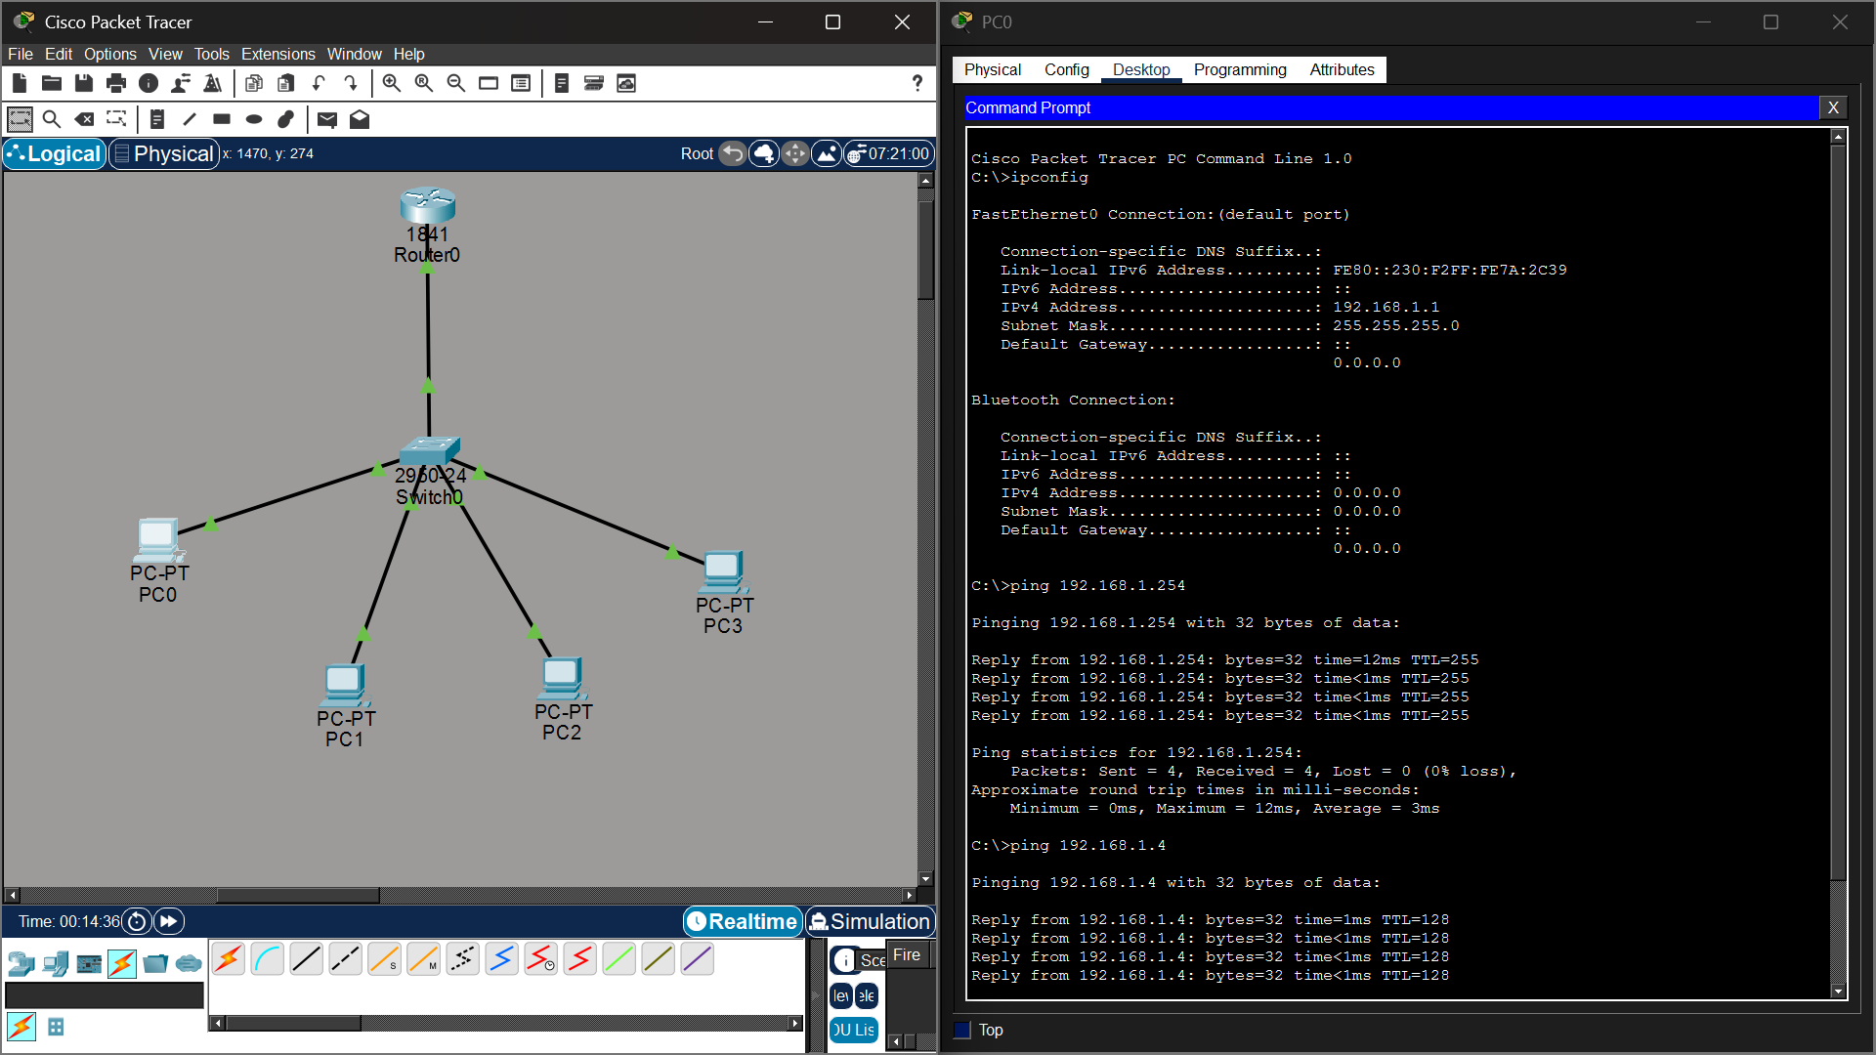

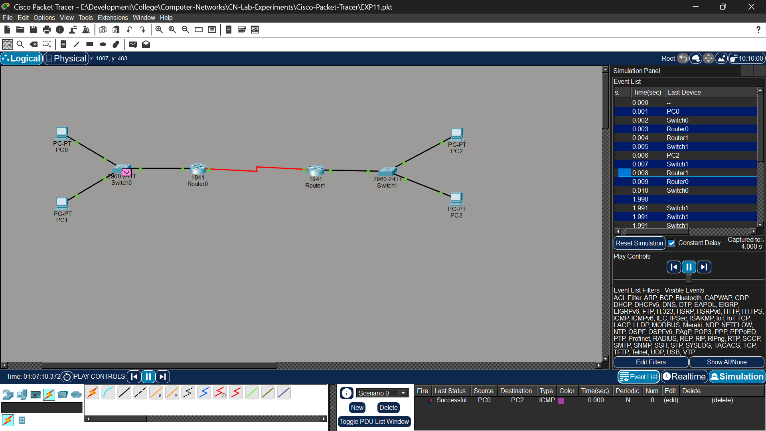
Experiment-11-Computer-Lab Router to Router Communication Using Static Routing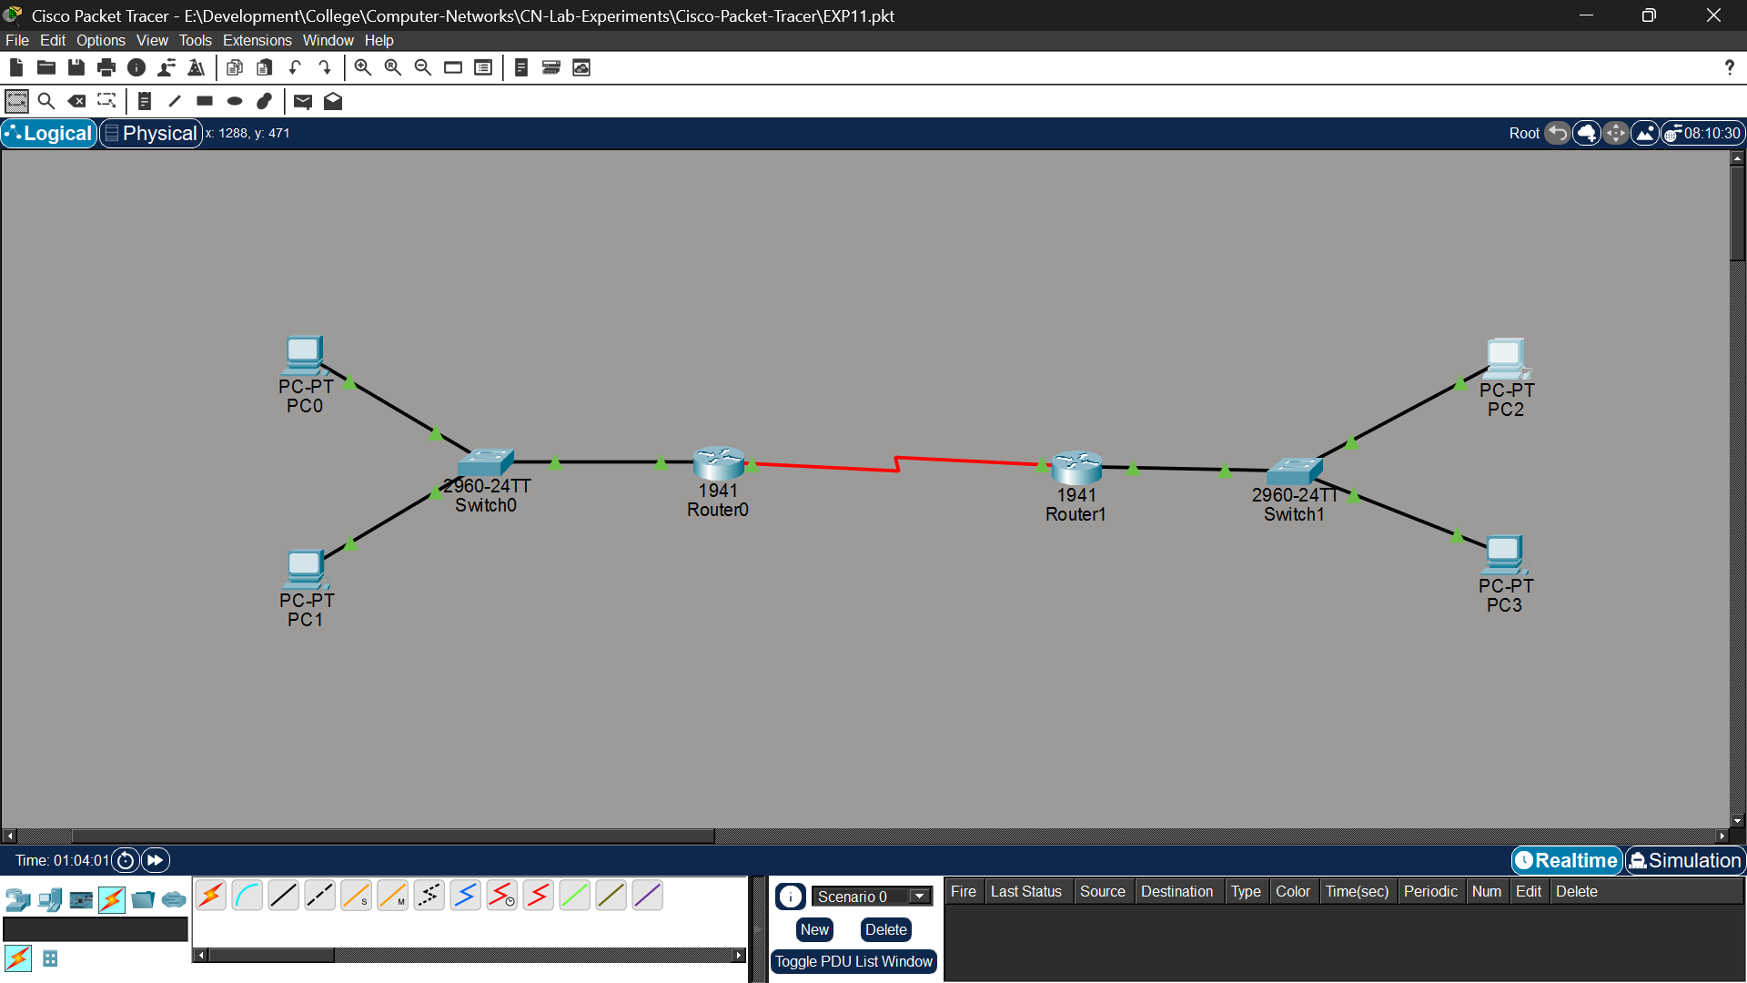
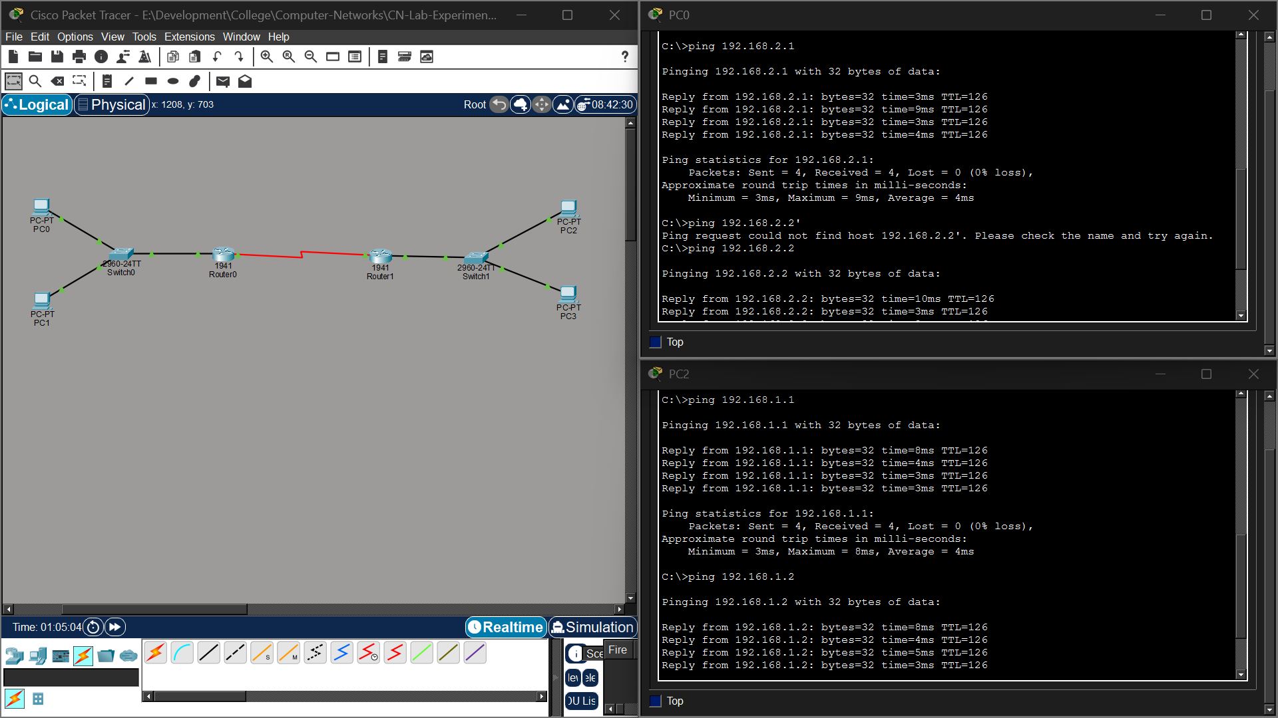

Experiment-12-Tcp-Functionalities
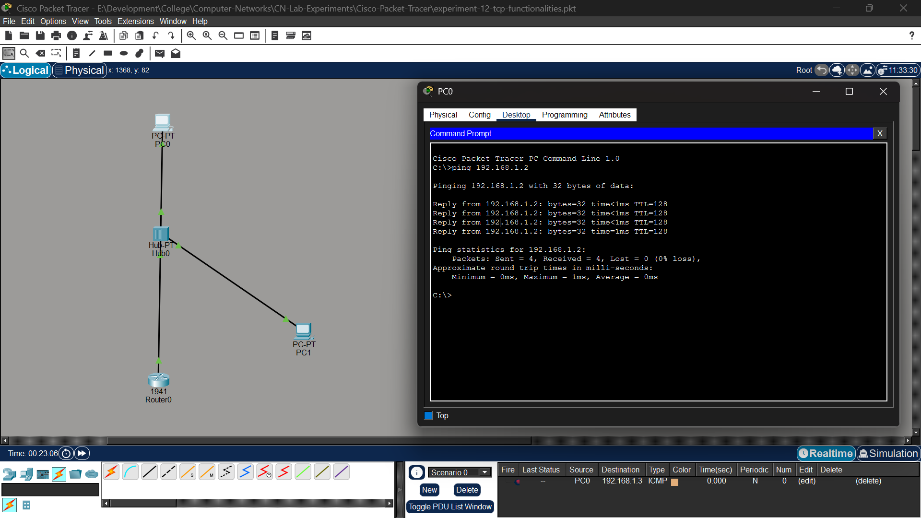

Experiment-13- Experiment-class-c-subnetting
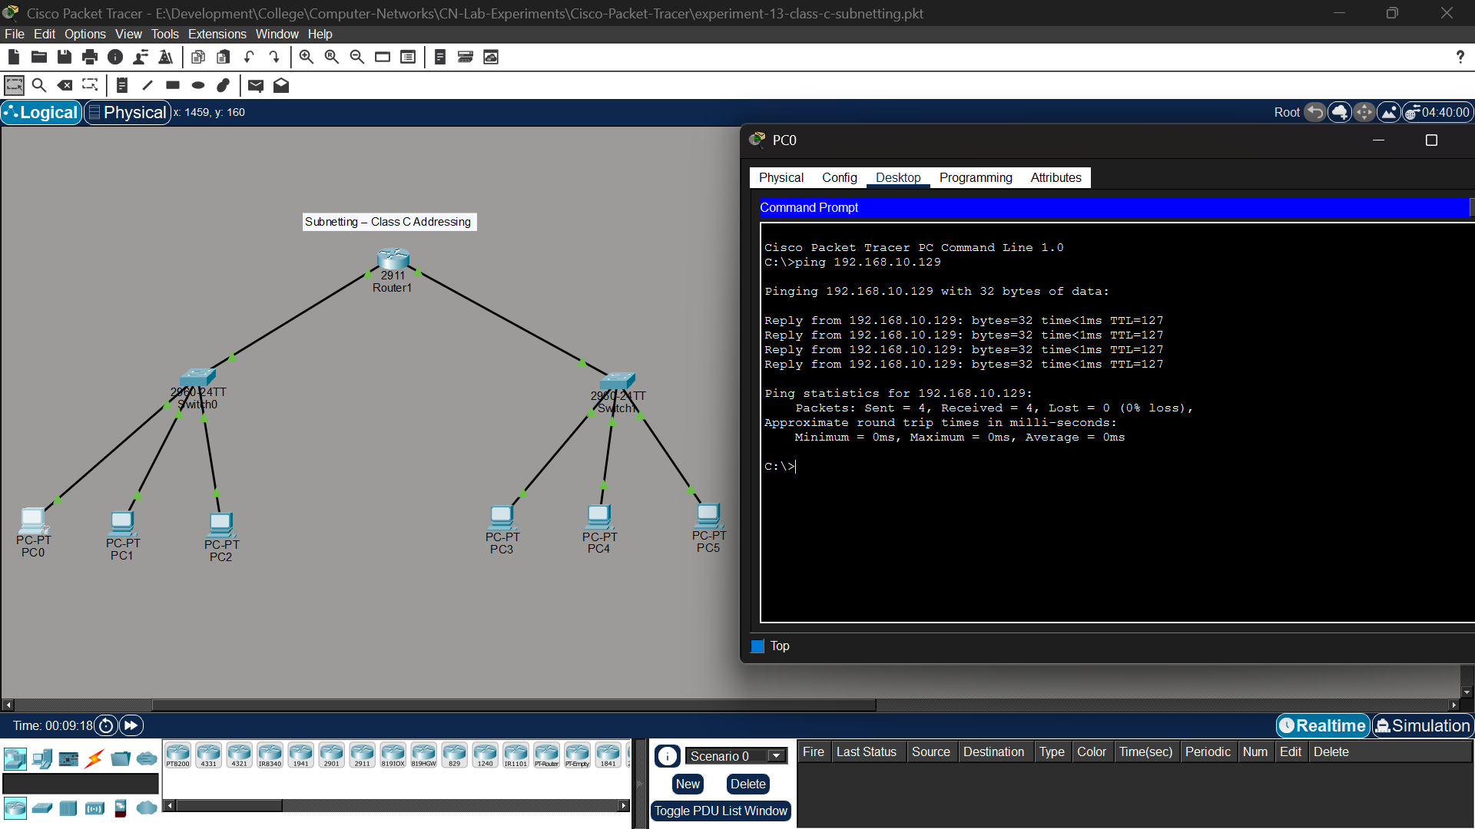

Experiment-14- xyz-company-network-design
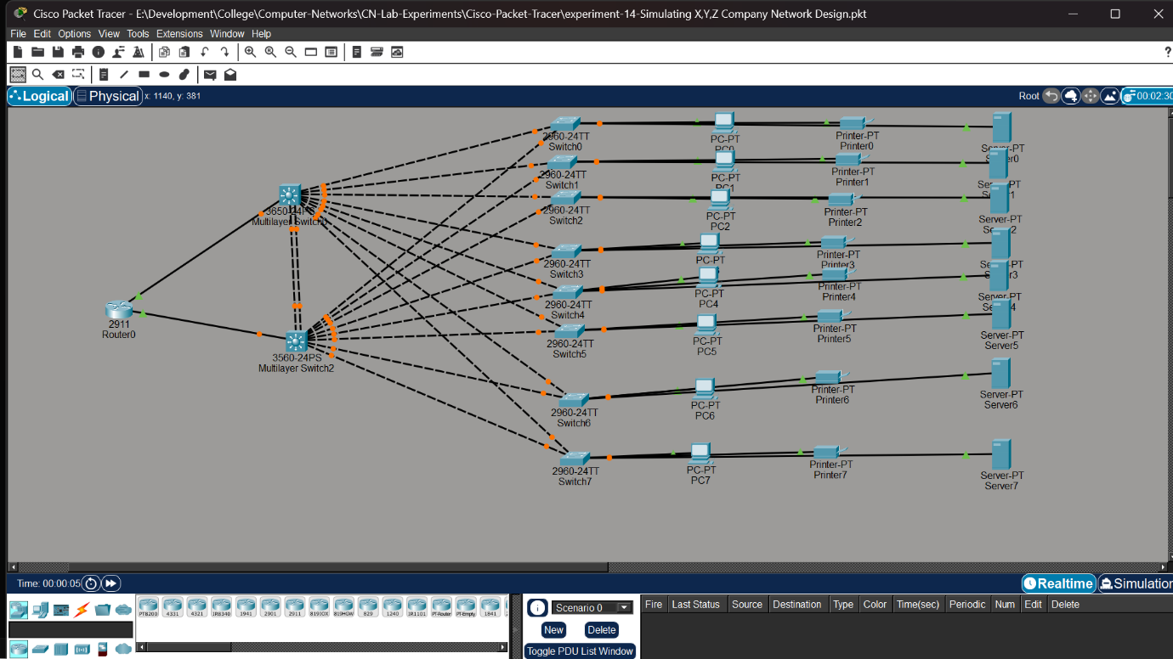

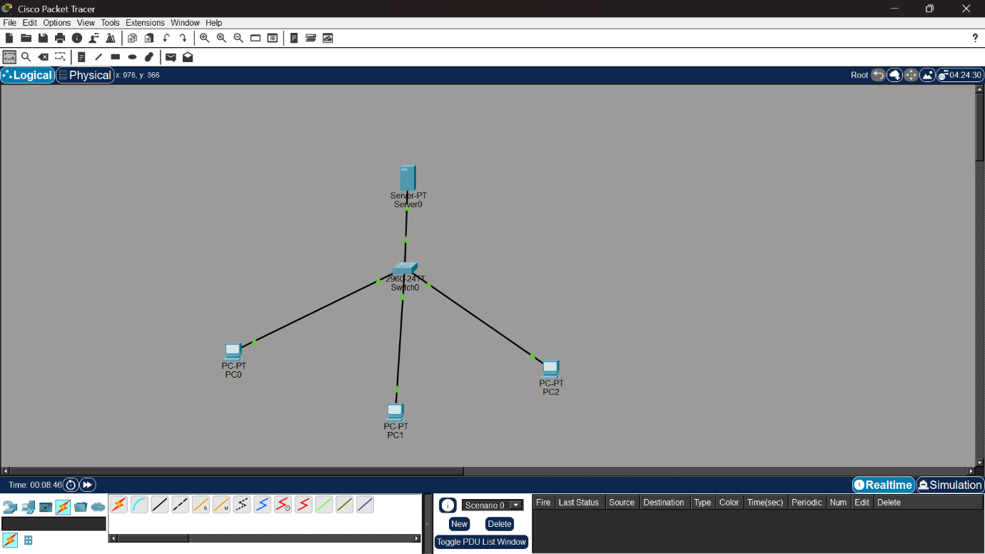
Experiment-15- DHCP Configuration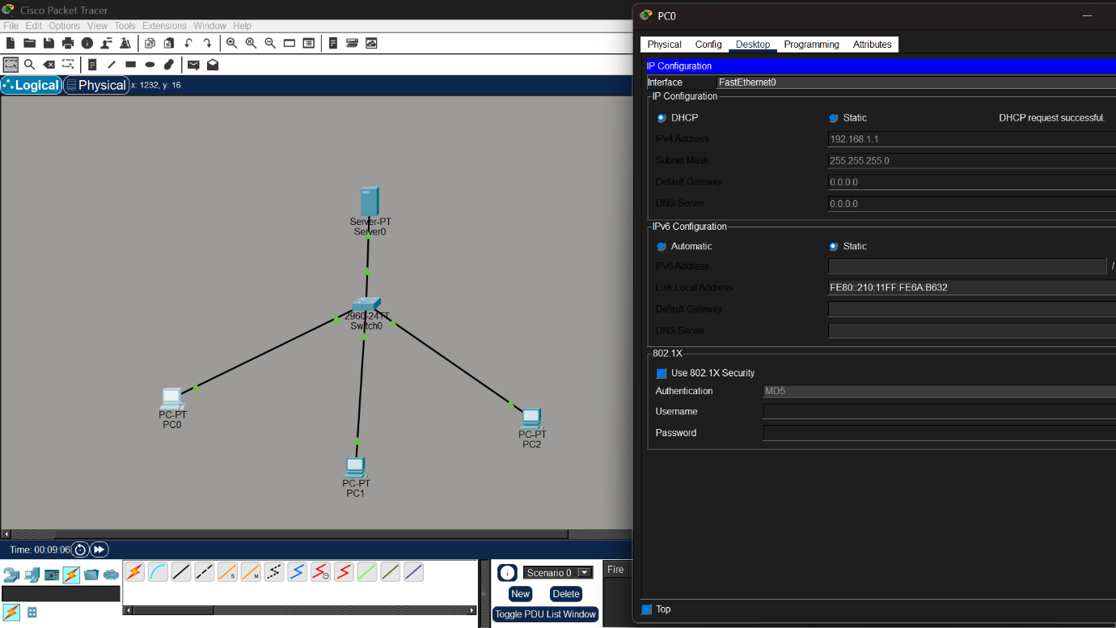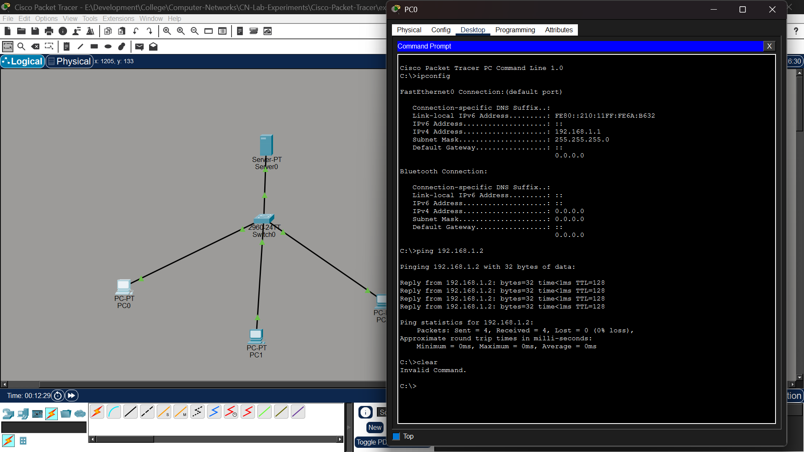

Experiment-16- Fire Wall
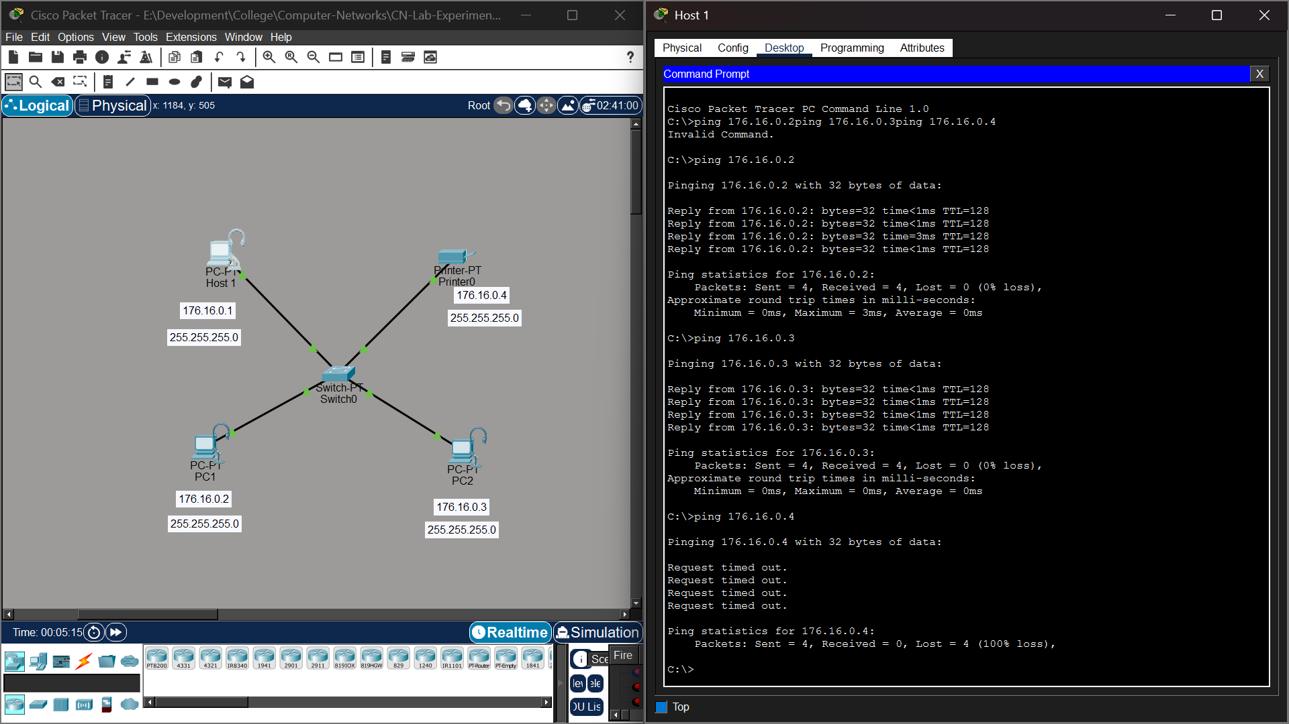

Experiment 17 – Firewall Configuration and Network Connectivity
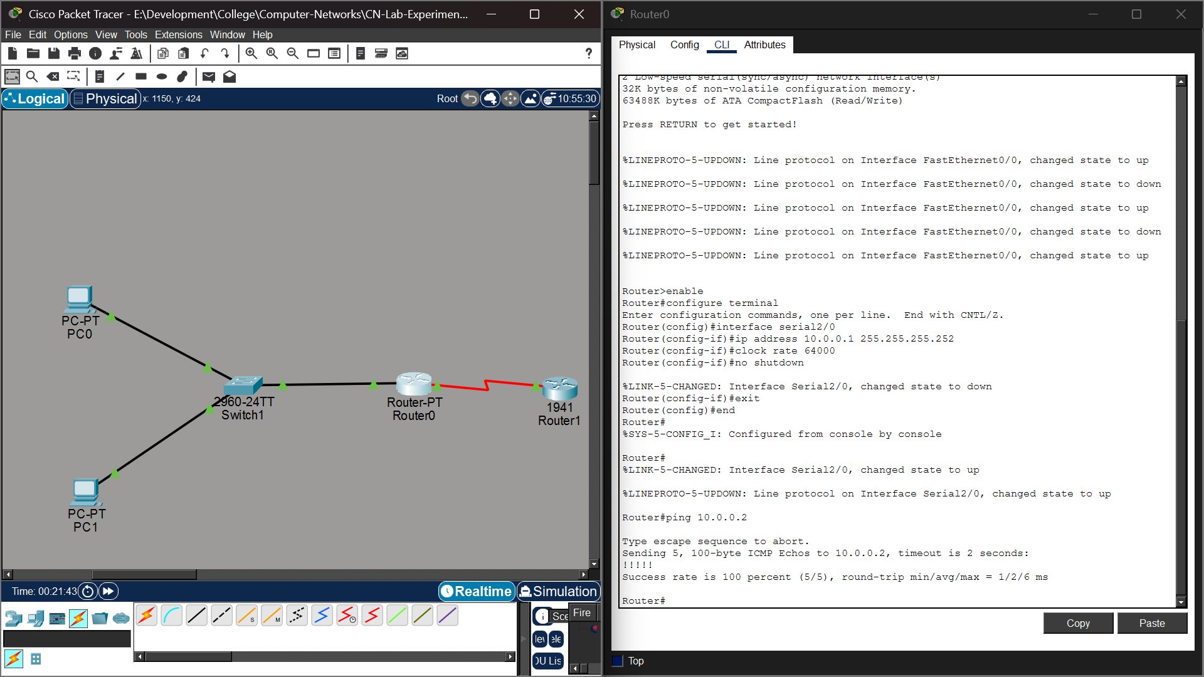

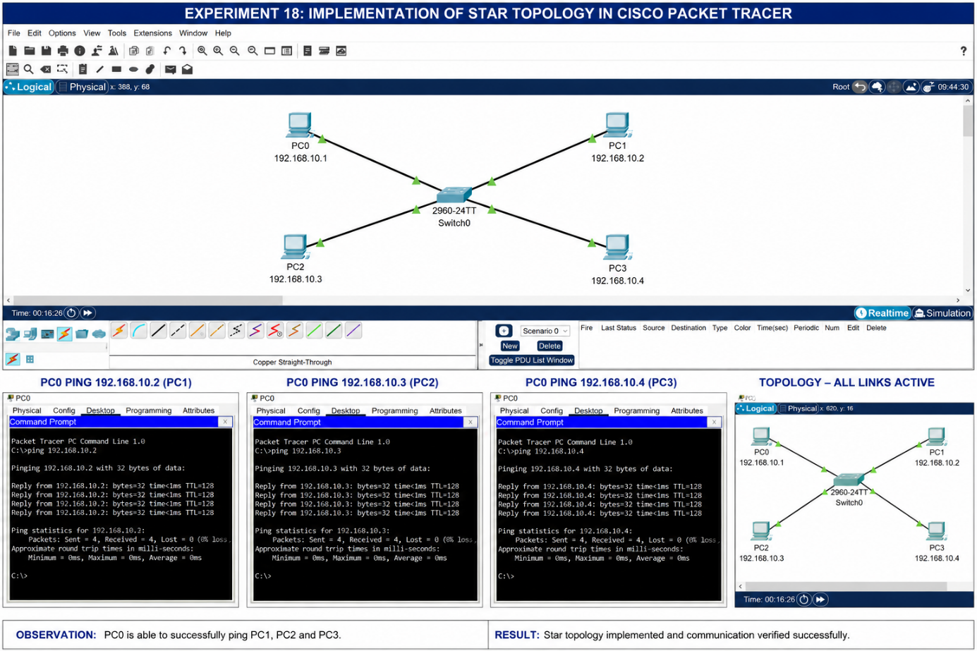
Experiment-18- Multimedia Network

Experiment-19- IoT based smart home applications

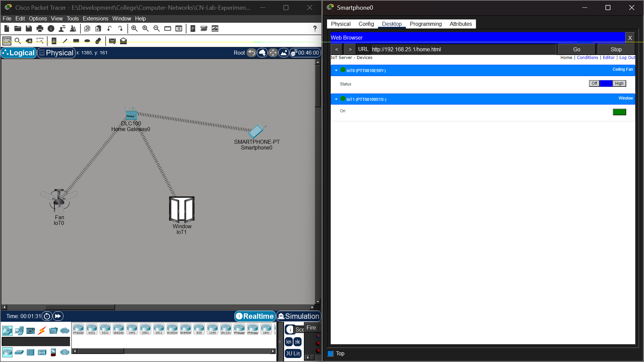

Experiment-20- IoT based smart home applications
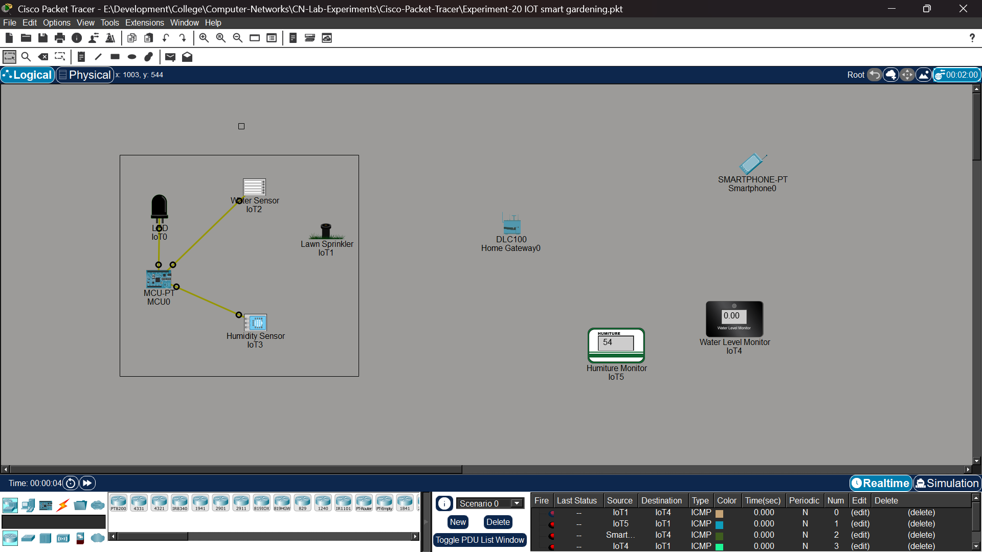
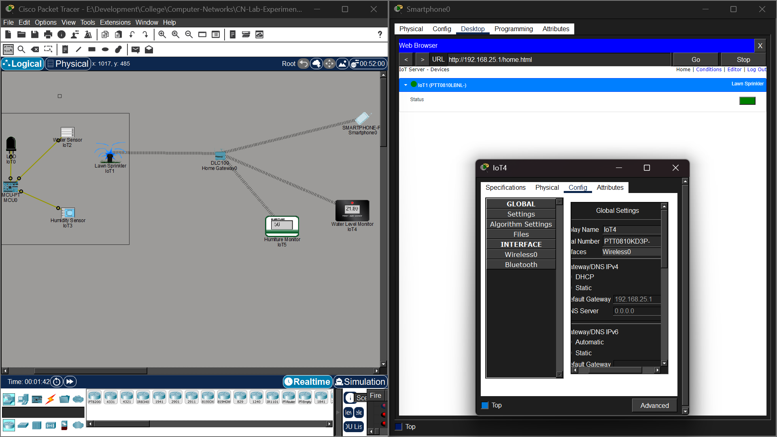

Experiment-21- IoT devices in networking
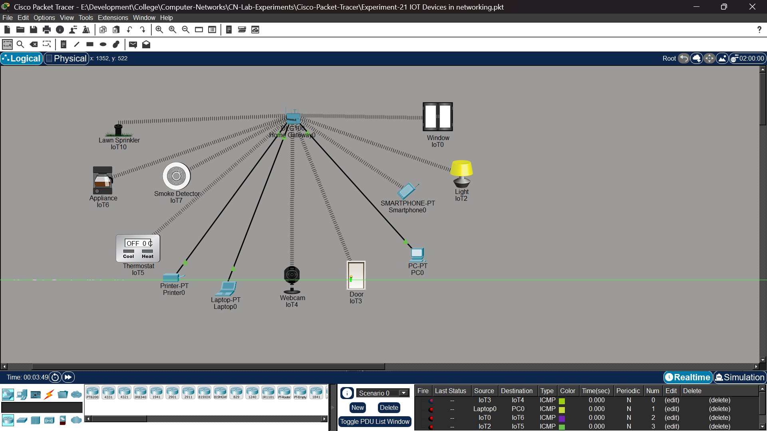
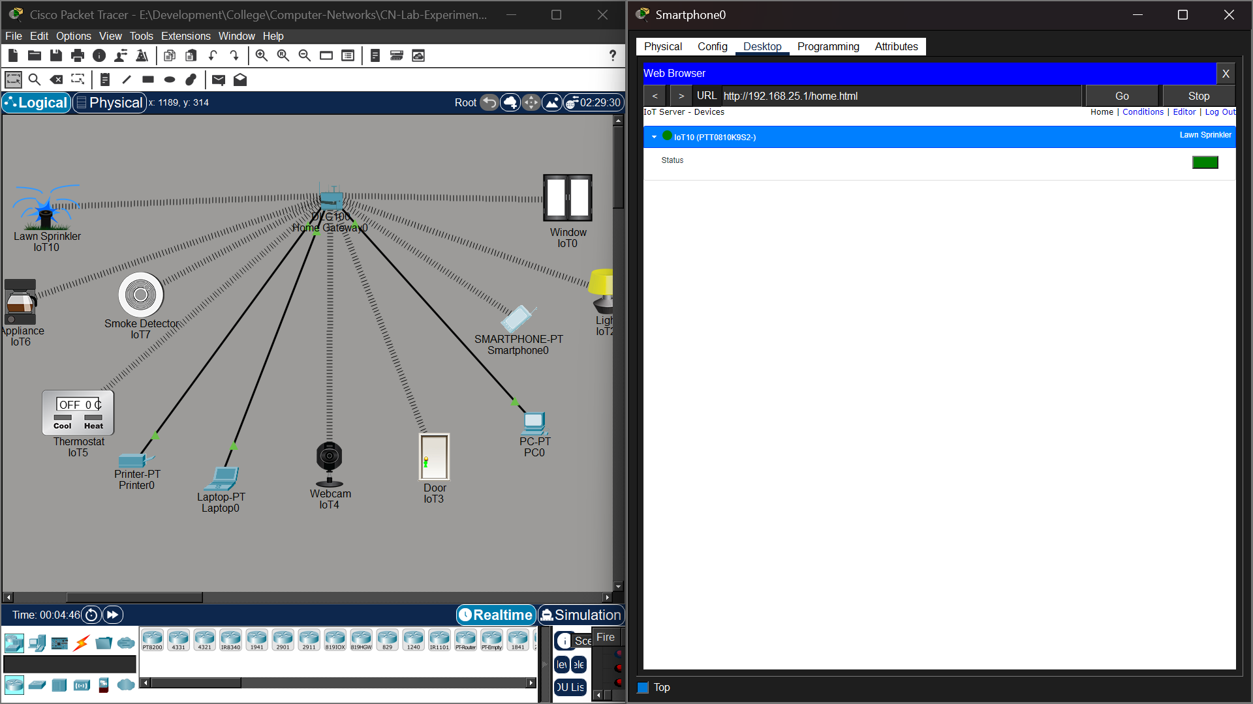
Experiment-22- IoT based AAA Local and Server 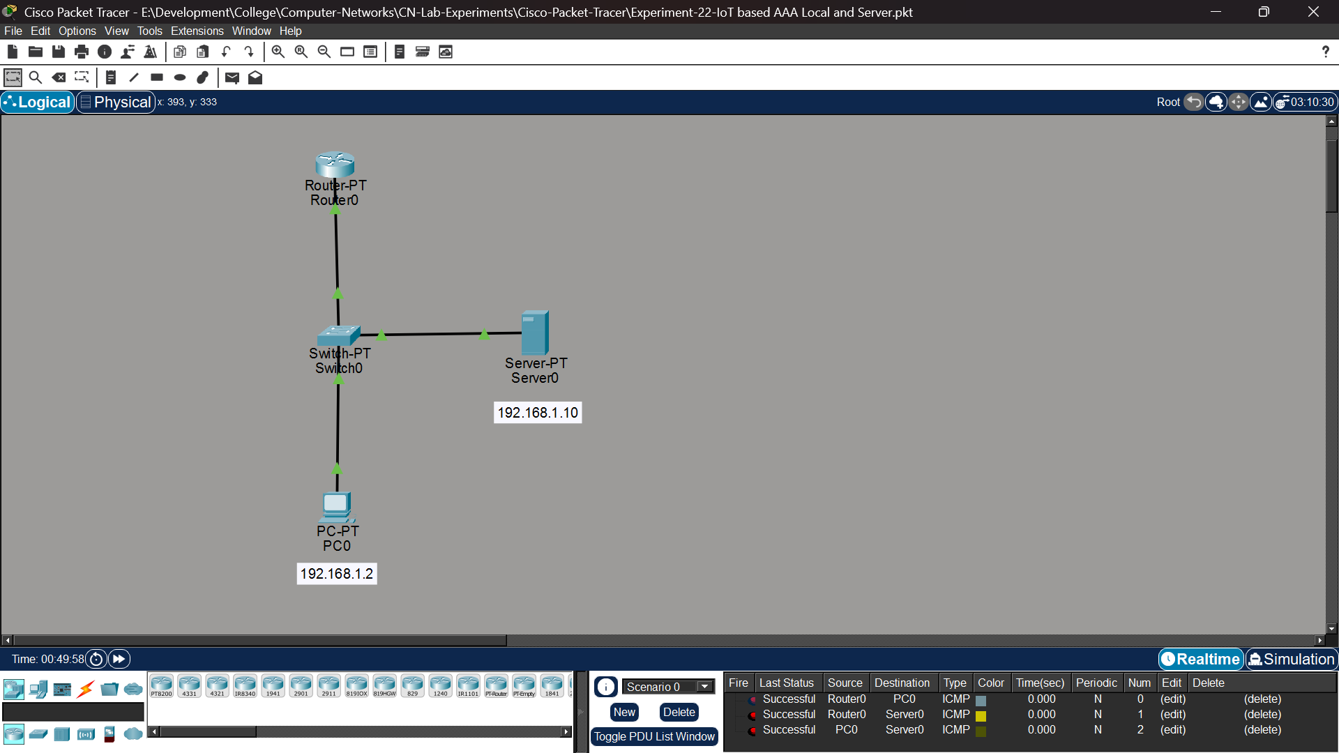 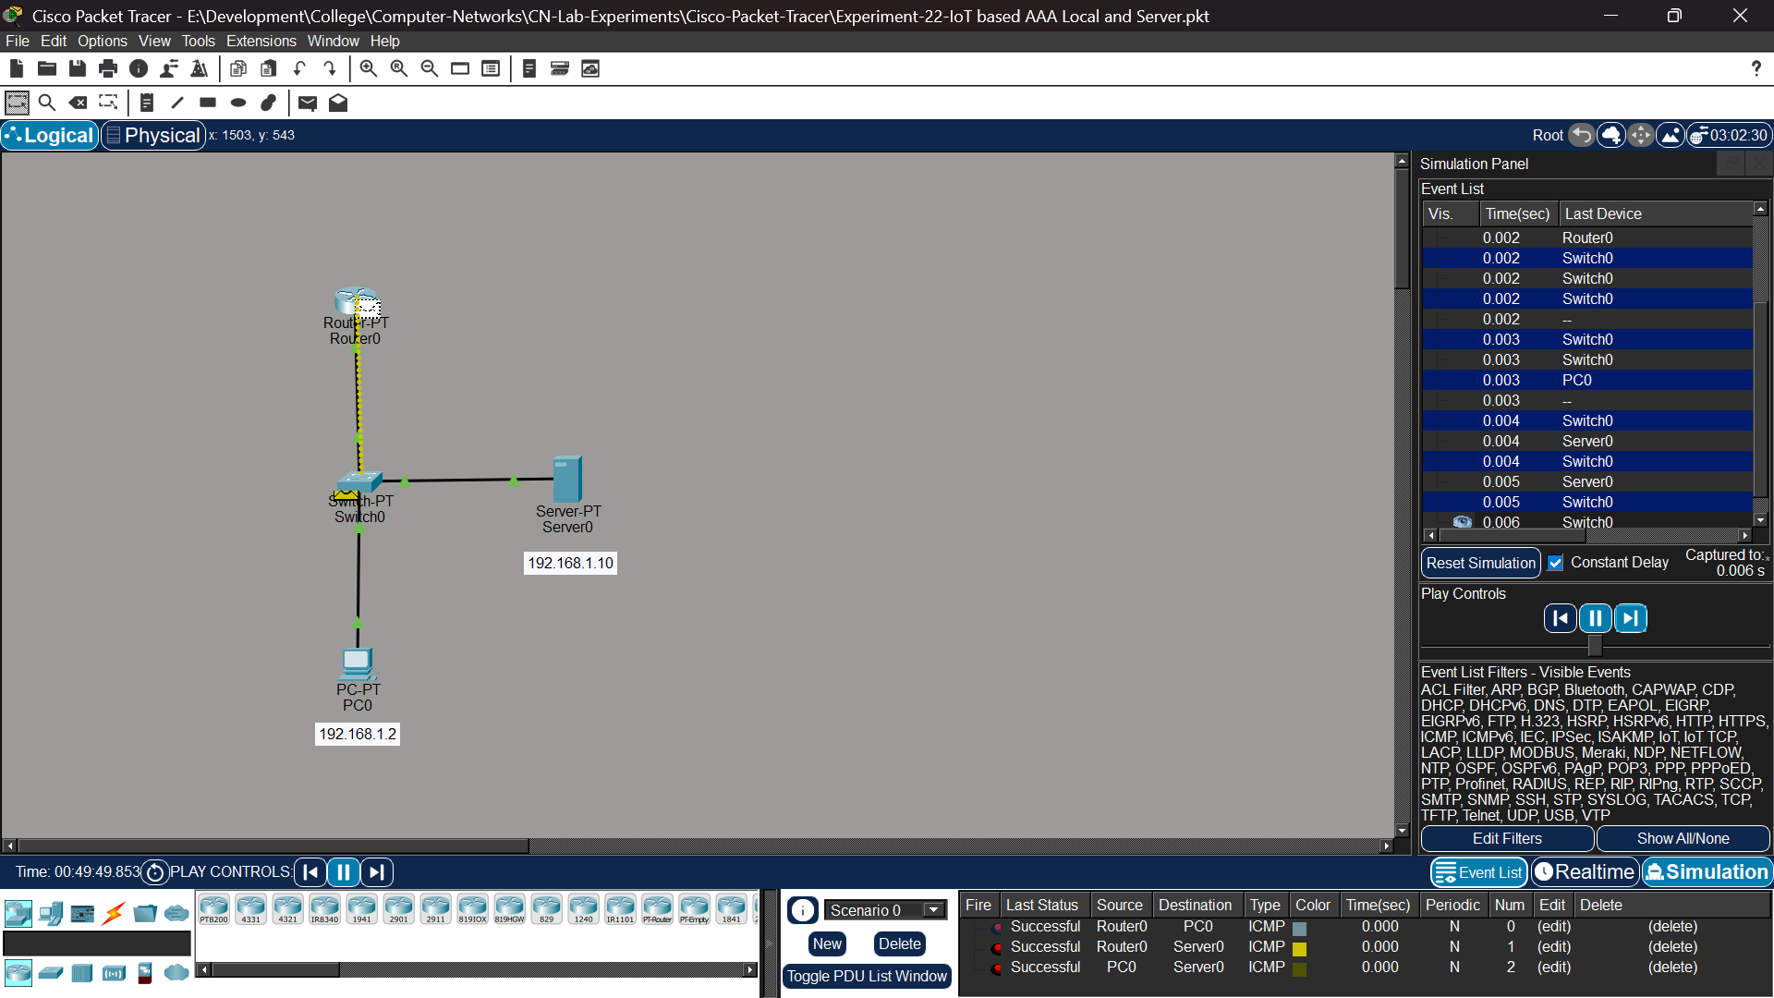

Experiment-23- TLP header analysis using Wire shark- TCP and UDP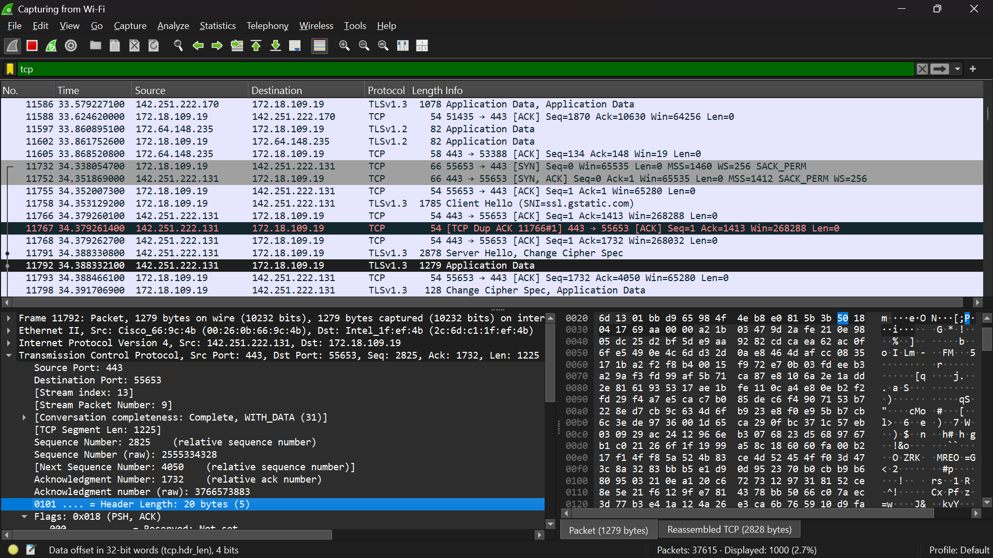
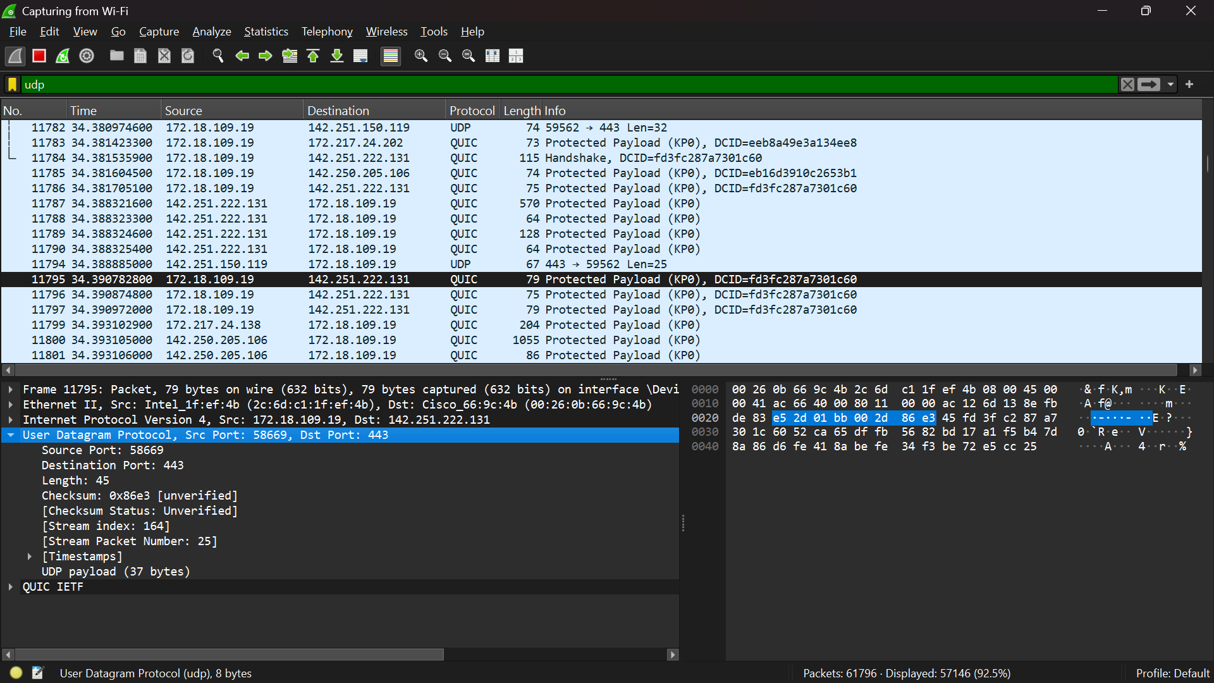

Experiment-24 - Network Layer Protocol Header Analysis using Wireshark – SMTP and ICMP
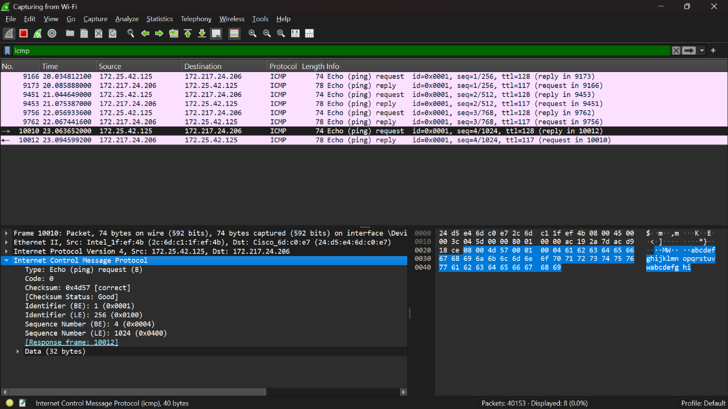
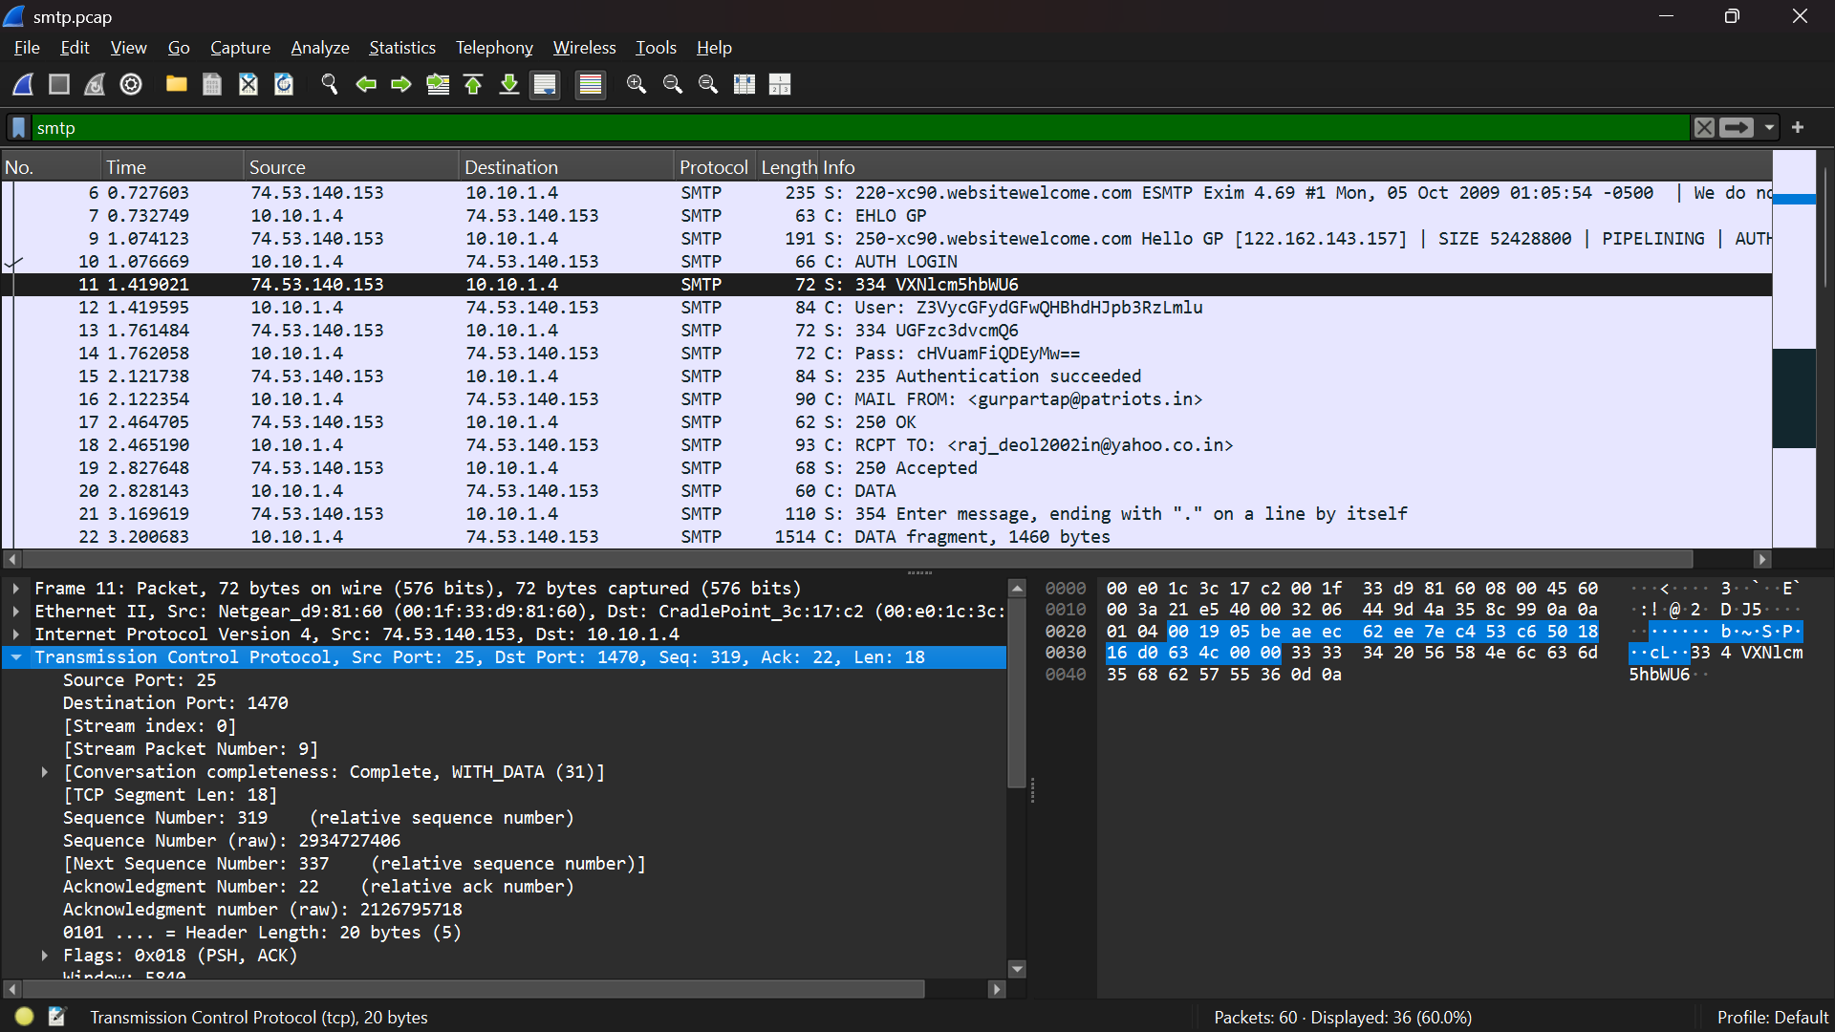

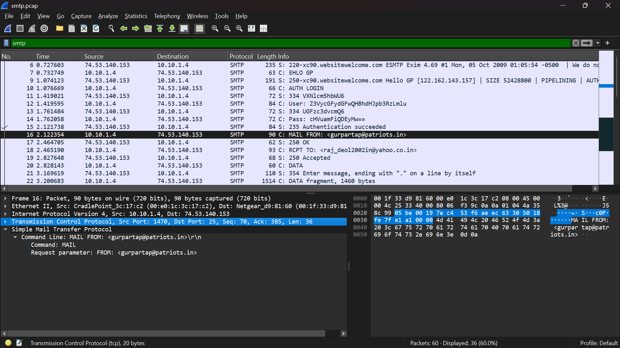

Experiment 25 – Network Layer Protocol Header Analysis using Wireshark – ARP and HTTP
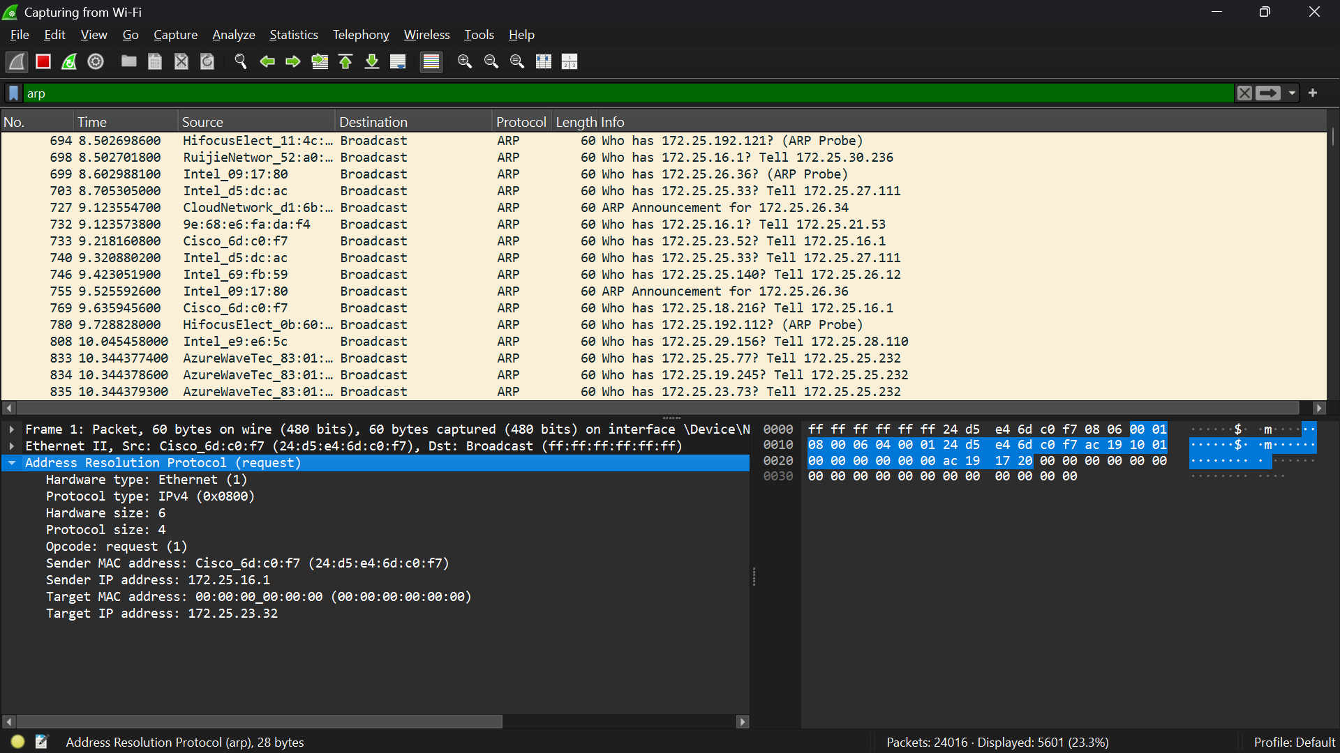

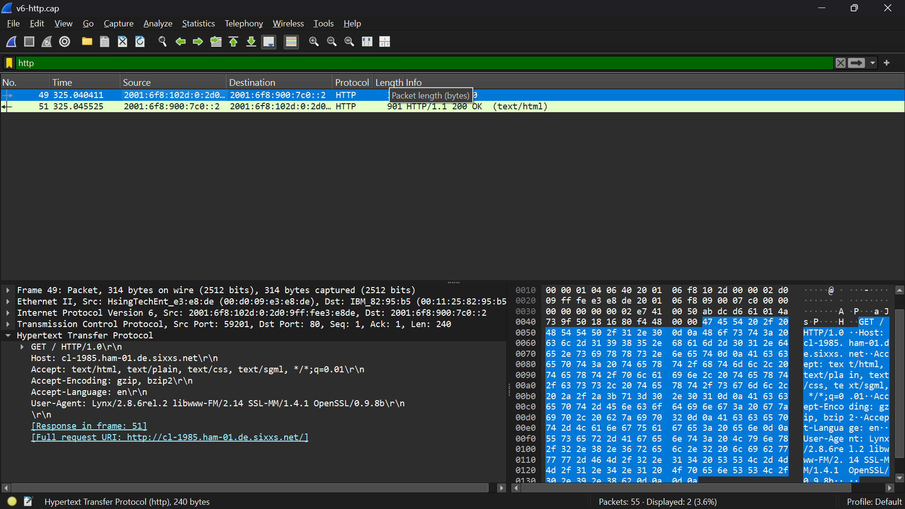

Experiment 26 – Date and Time Display from Client to Server using TCP Socket
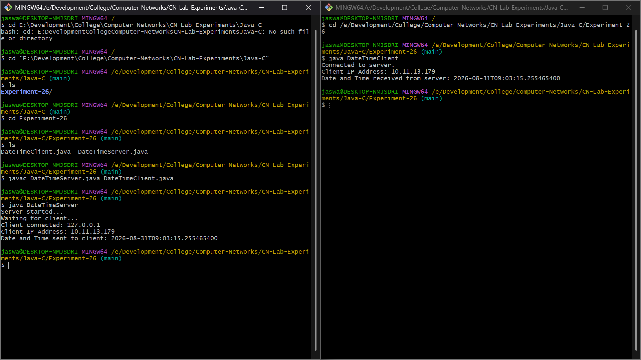

Experiment 27 – Implementation of DNS Server and Client using UDP Socket
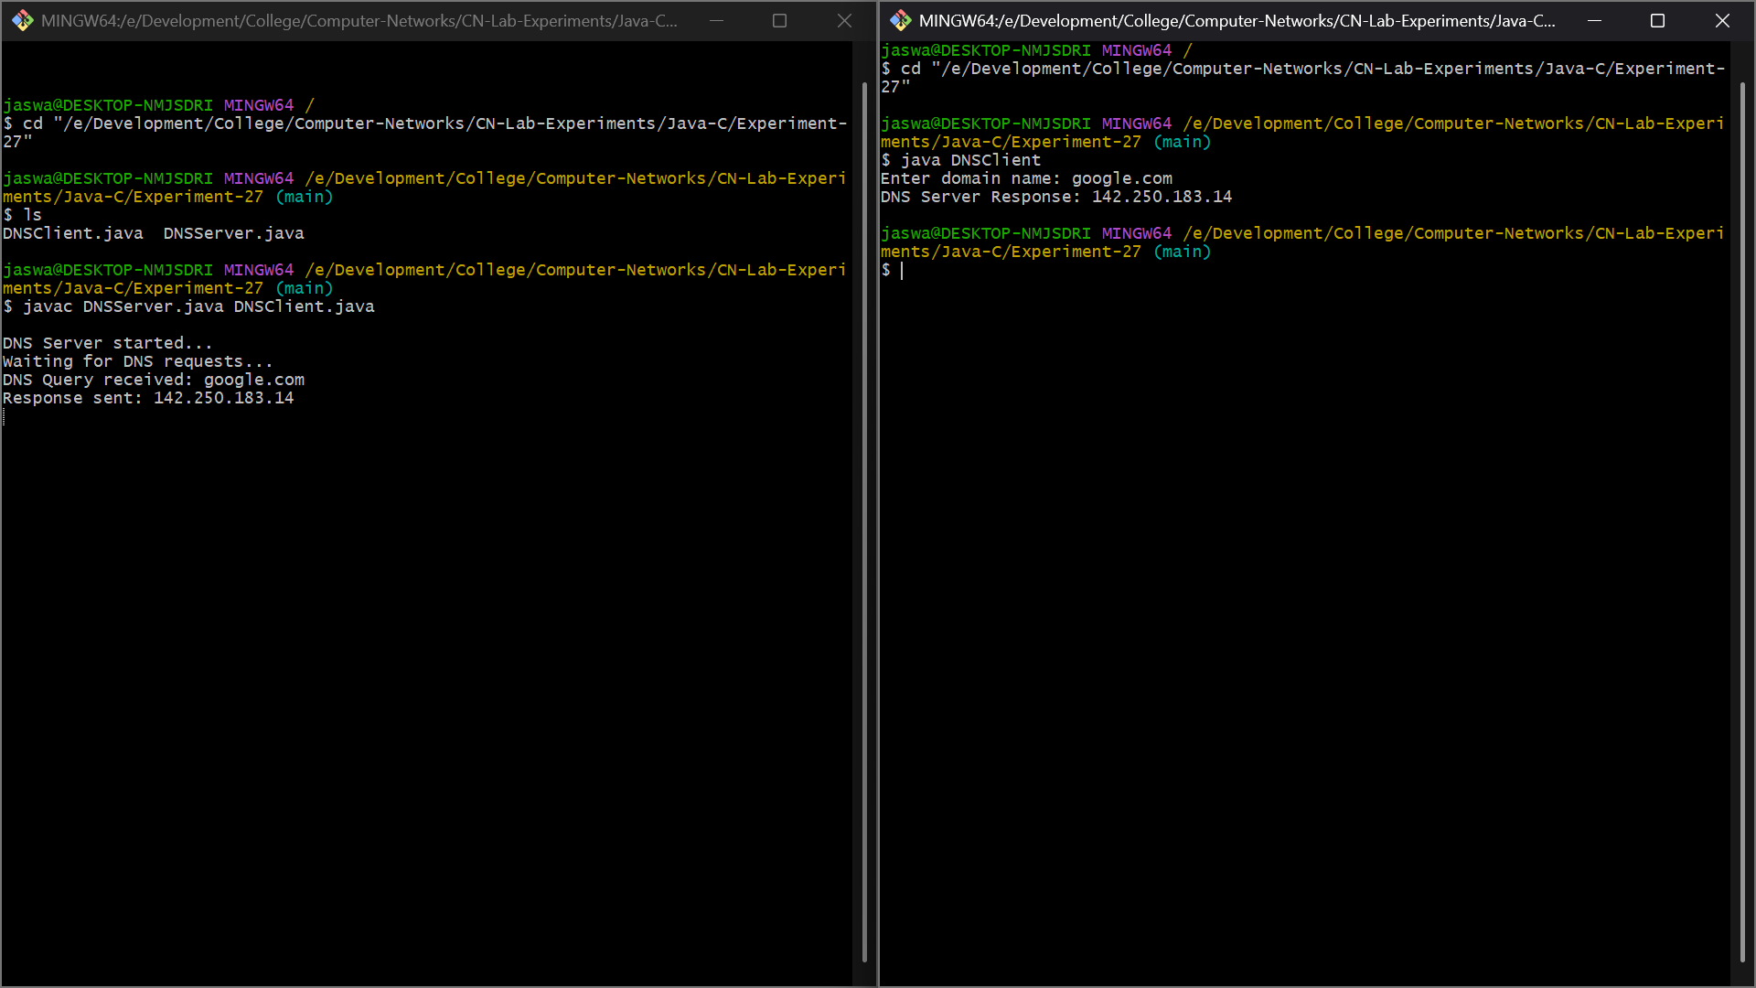
Experiment 28 – DNS Client to Resolve a Given Hostname using Java
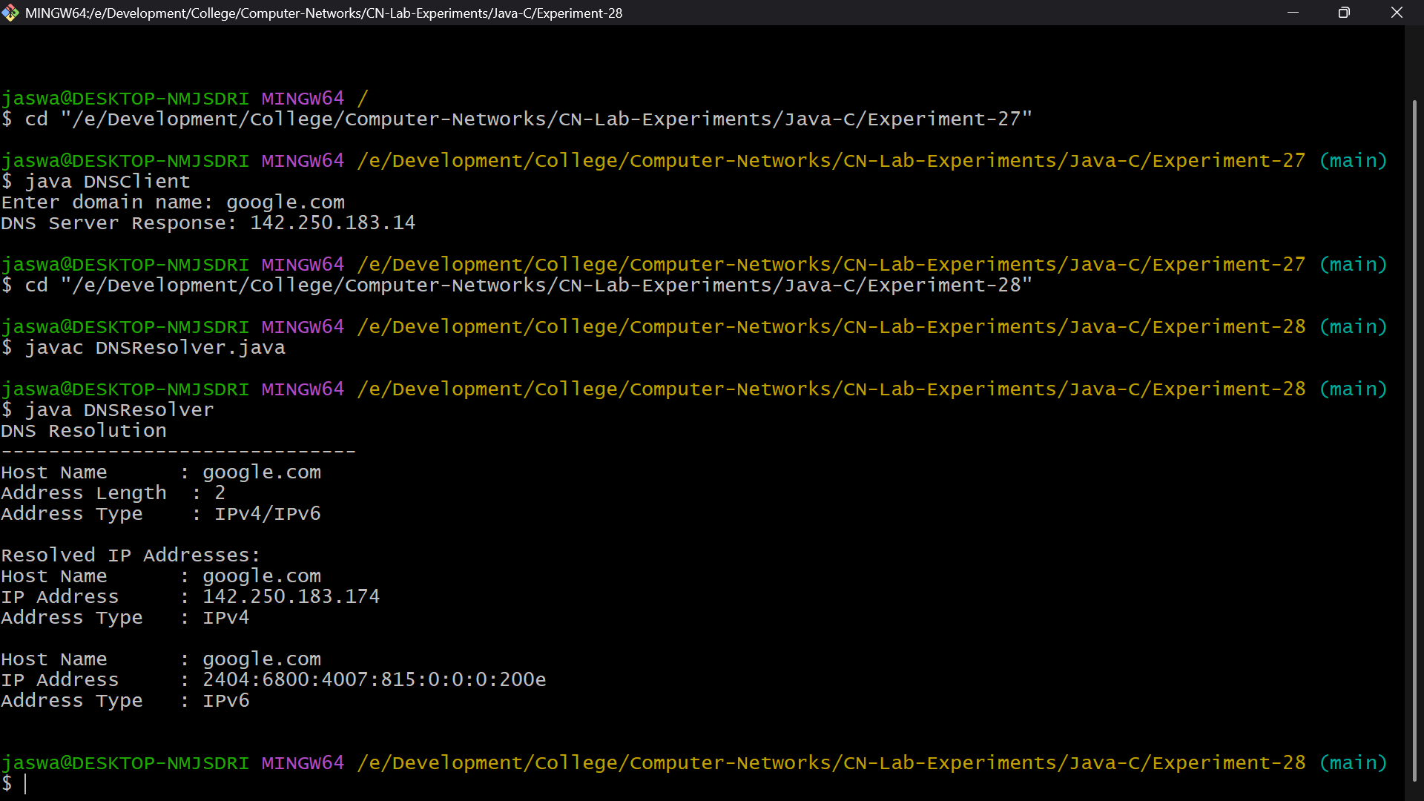

Experiment 29 – TCP Echo Server and Client using Java
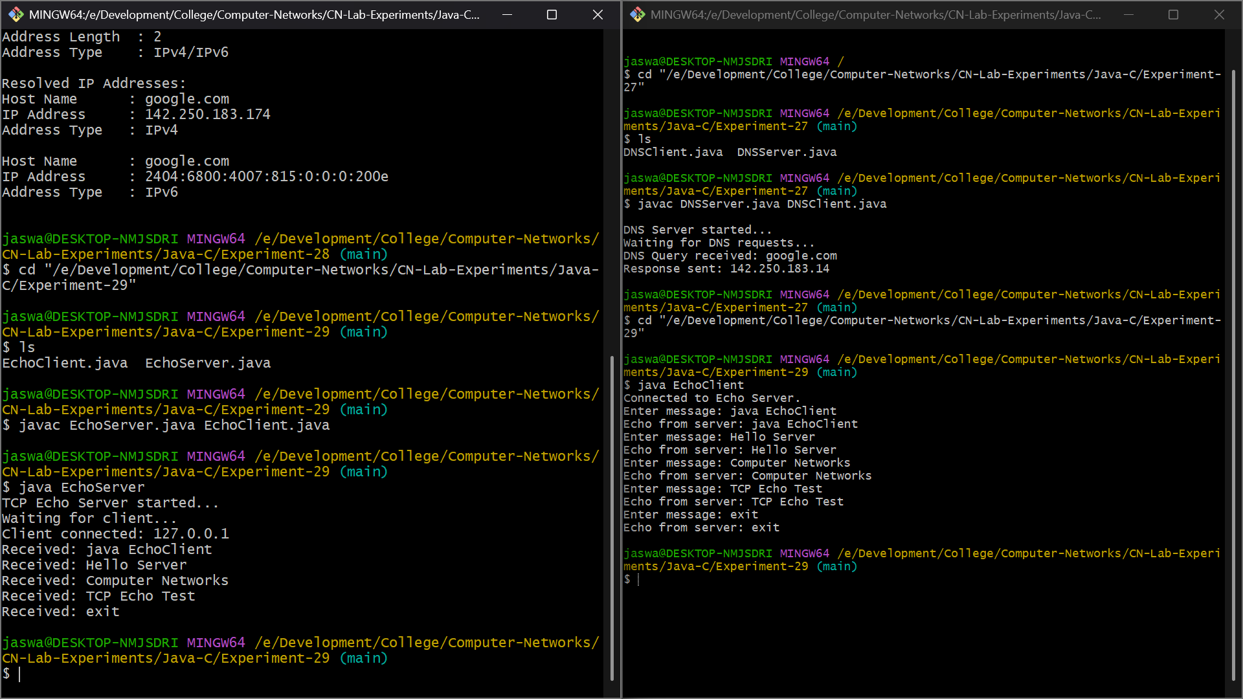
Experiment 30 – TCP Chat Client and Chat Server using Java
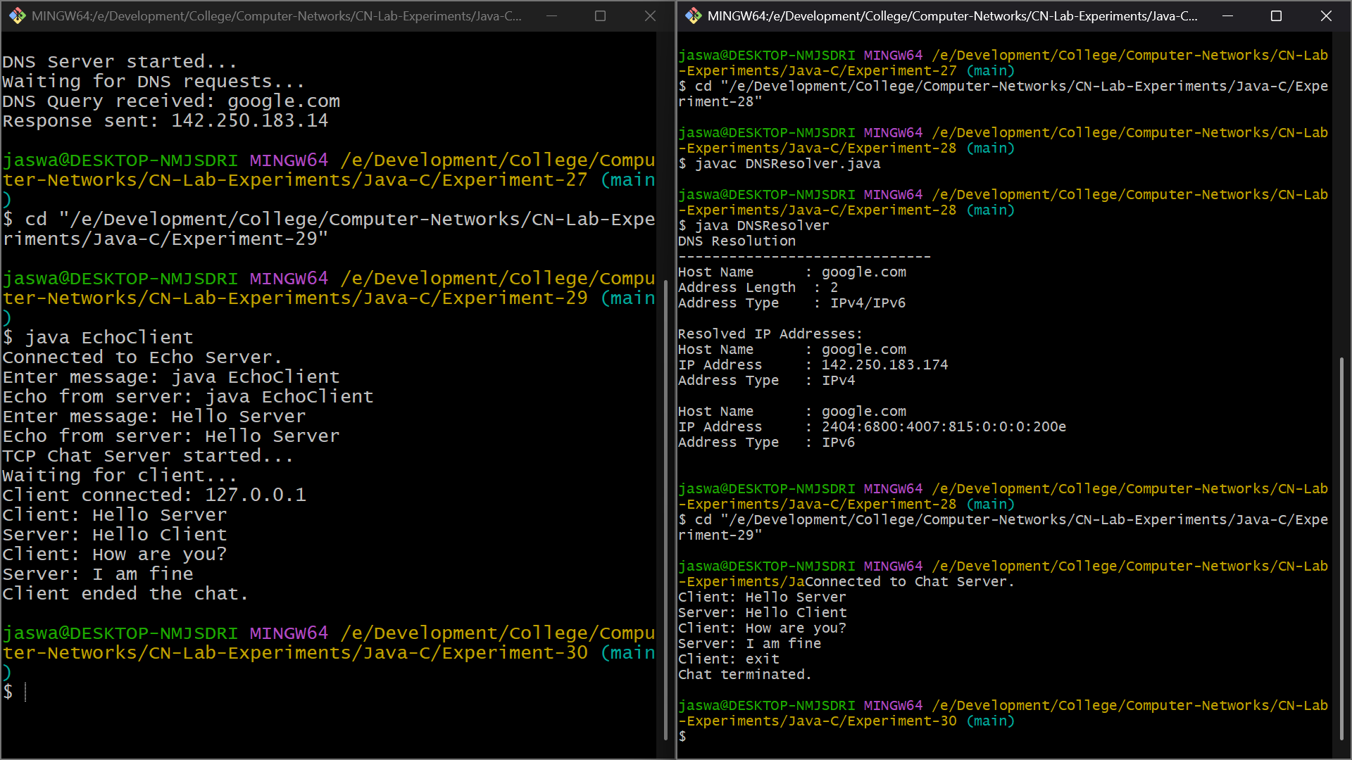

Experiment 31 – Implementation of ARP Protocols in Java
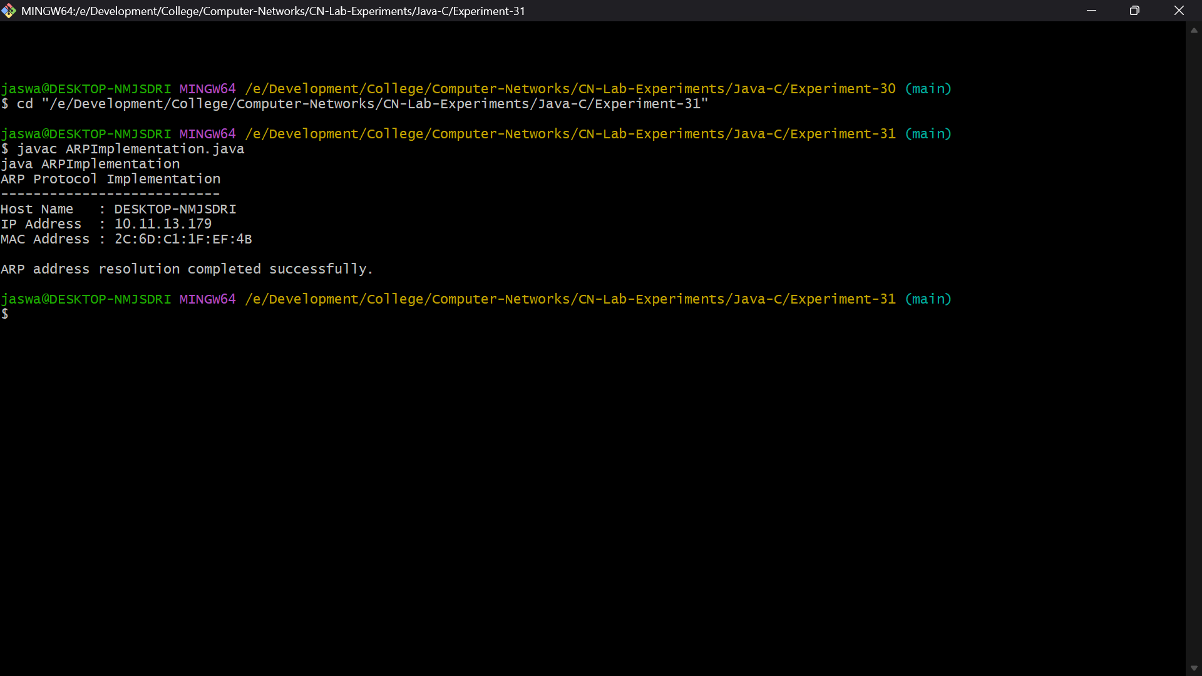
Experiment 32 – Implementation of Bit Stuffing Mechanism using Java
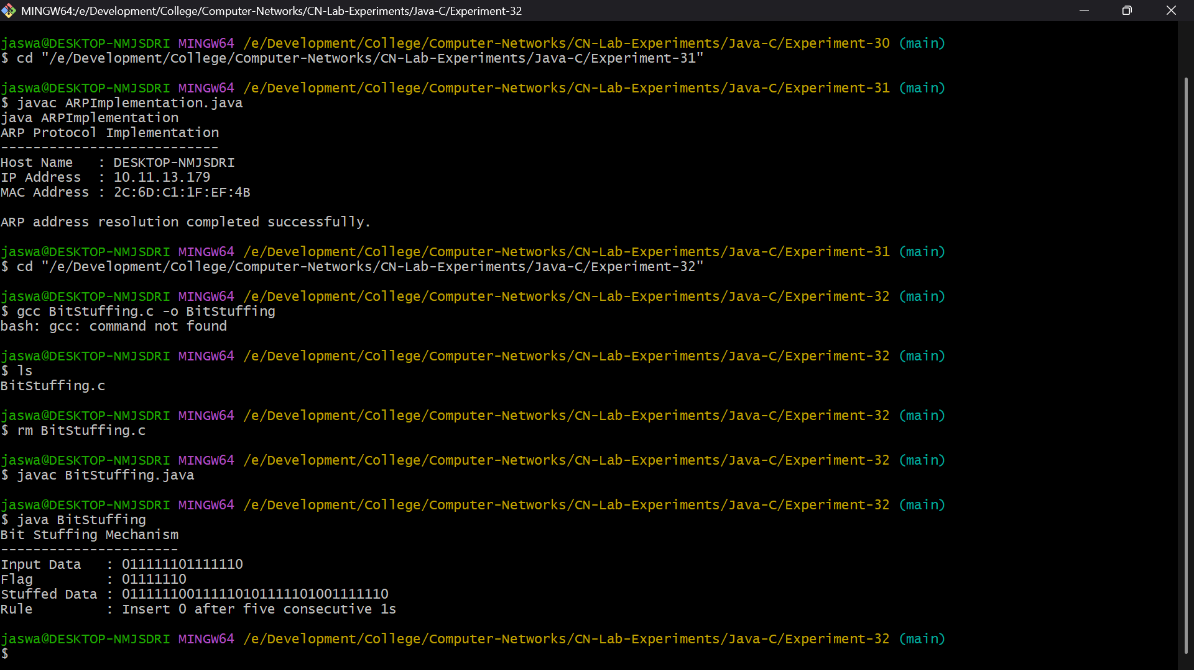

Experiment 33 – TCP File Transfer using Java
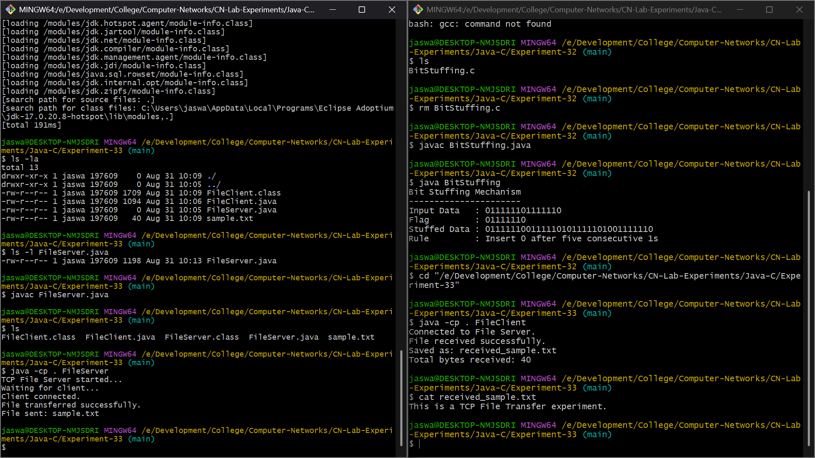
Experiment – 34: CRC Error Detection / Cyclic Redundancy Check (CRC) Implementation
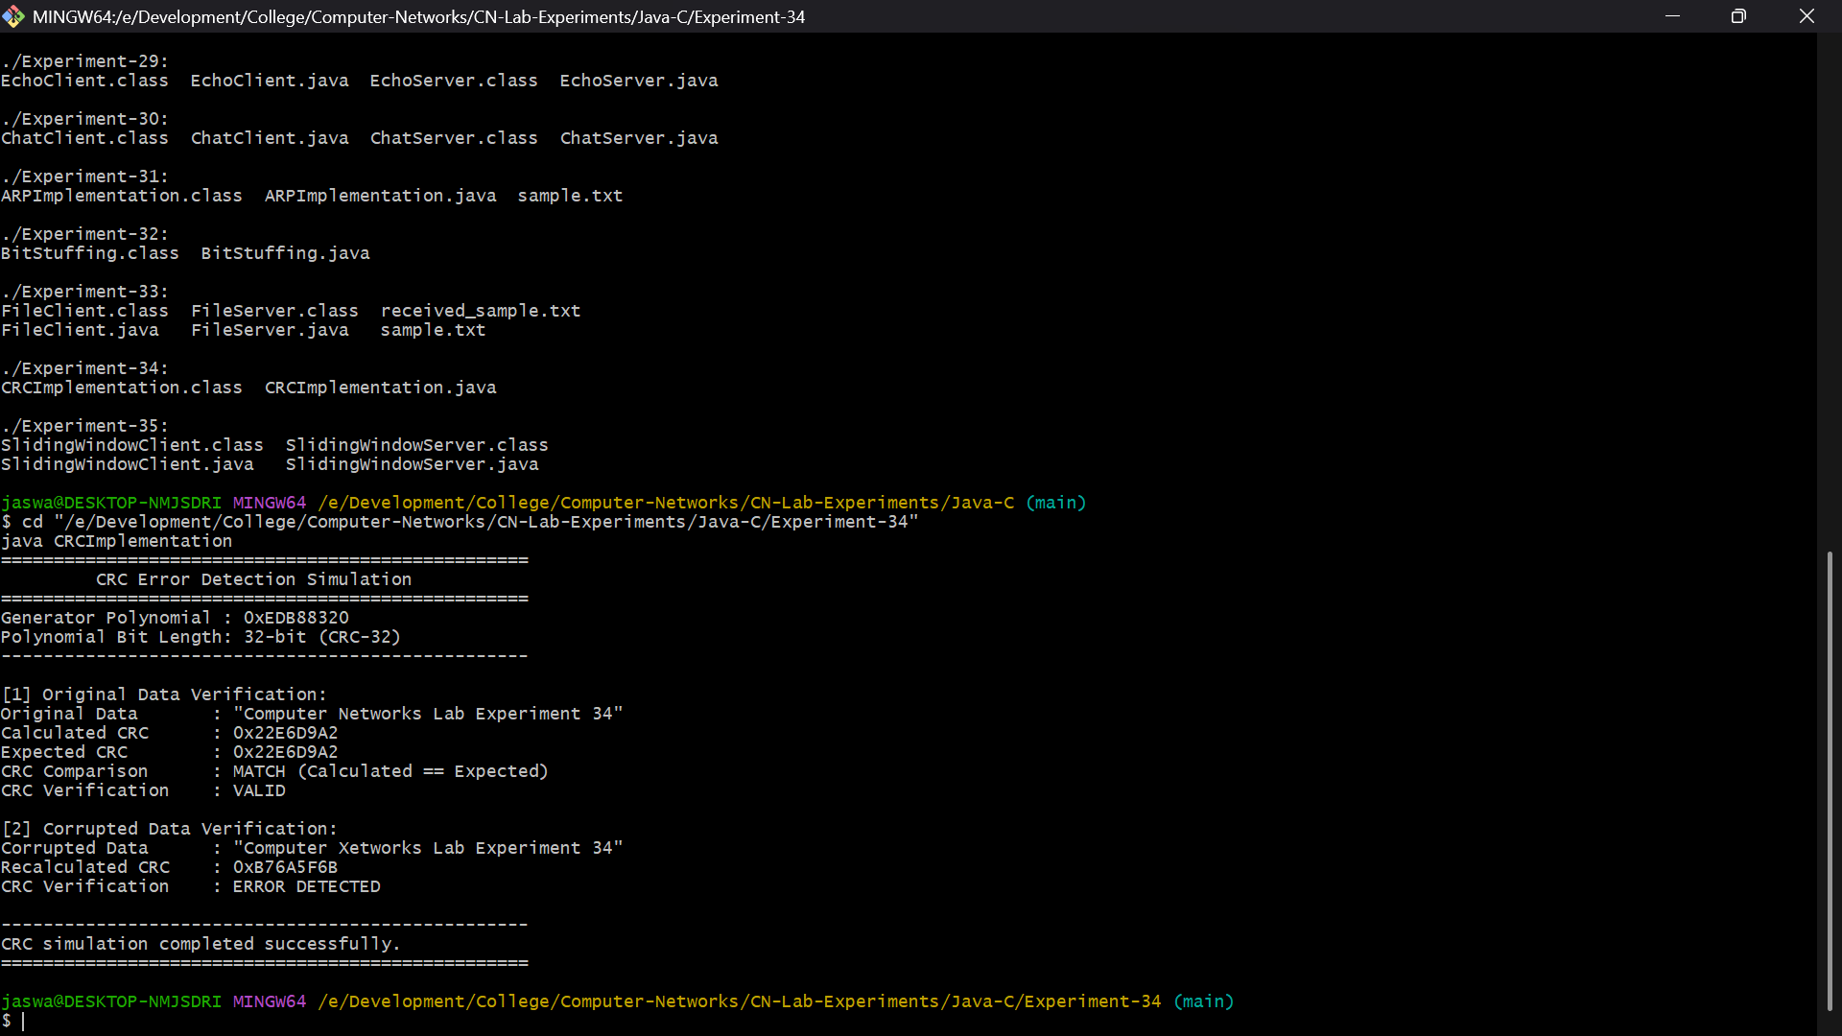

Experiment – 35: Implementation of Sliding Window Protocol
